Plant biotic and abiotic stresses combinations and their management: Review article

Haggag, W. M.∗

Plant Pathology Department, National Research Centre, Cairo, Egypt.

Haggag, W. M. (2024). Plant biotic and abiotic stresses combinations and their management: Review article. International Journal of Agricultural Technology 20(1):105-122.

Abstract Studying the environmental pressures that affect plant production needs to be prioritized since climate change is the main obstacles to agricultural productivity. There are two types of environmental stresses that affect plants: biotic and abiotic stresses. Both stresses from biotic as pathogens and abiotic as temperature, UV rays, salinity, floods, droughts, heavy metals, etc. reduced the morphological characteristics and yield of the plant. Abiotic stressors can change plant-pest interactions by making the host plant more vulnerable to pathogenic organisms, and weeds, as well as by lowering its capacity to compete with them. The opposite is also true; certain pests may change how plants react to abiotic stressors. The impact of concurrent abiotic and biotic stresses conditions on crop yield is therefore crucially understood through systematic investigations. Additionally, when several stressors occur at once, the effects on plants are highly complicated since they are influenced by a variety of signalling pathways, some of which are antagonistic and may even work against one another. Plants have created a multitude of coping mechanisms to deal with these challenges. Many studies have been conducted to identify and interpret plant assimilate partitioning and stress-tolerant plant genotype, which are critical for understanding the intricacy of a plant's response to biotic and abiotic stressors. In addition, a number of studies have demonstrated that plant nutrition, silicon, microorganisms, microbiome, and plant growth regulators all contribute to increased plant growth, phytohormone synthesis, and the expression of genes linked to the dehydration response and antioxidants—all of which can enhance biotic and abiotic stress tolerance. Utilizing nanoscale goods like nanofertilizer, nanofungicides, nanoherbicides, and nanopesticides. One such innovative technique to increase agricultural output under various biotic and abiotic stress situations is nanotechnology. This review covers a wide range of subjects related to biotic and abiotic stress reactions in plants with a focus on problems and their management.

Keywords: Plant biotic and abiotic stresses, Climate change

Introduction

According to Atafar et al. (2009), stress is defined as any internal or external constraints can lessen the capacity of a plant to transform energy into biomass and limit the pace of photosynthetic activity. There are several stresses that can affect plants., which fall into two main categories: biotic and abiotic. Any climatic variation or extreme occurrence might alter the ideal environment for plants, resulting in slower plant growth, undeveloped leaves and roots, and decreased agricultural output (Gray and Brady, 2016). Global climate change has accelerated over the past few decades, potentially posing greater risks to agricultural growth, productivity, and yield. Additionally, it helps diseases and pests spread (Scheffers et al., 2016). Determining the nature of these interactions is essential to understanding the effects of combined biotic and abiotic stresses on plants. Mittler et al. ,2006; Suzuki et al., 2014) collected the impacts of many abiotic and biotic stressors on plant growth and production into a "stress matrix". This matrix illustrates the potential positive and negative effects that various stressor combinations may have on plants. Therefore, to create plants with higher resilience to abiotic stresses, it is vital to identify physio-morphological traits that are affected by combined forces. Therefore, it is crucial to look at how crop plants react to the unfavourable environment in the face of these ongoing and rapid changes in climate. In this article, we give a comprehensive overview of various stressors, combinations, and how they are managed in relation to agriculture crops.

Principal stressors that affect plants

Biotic and abiotic stresses

Biotic stress
They are brought on by other living things, such microorganisms as pathogens, bacteria, fungus, live outside influences like plants and weeds, animals, insects, and so on. A plant's growth and health can be significantly impacted by a number of diseases, including bacteria, viruses, and fungi. These infections can cause a range of symptoms, such as wilting, discoloration, and even plant death. In addition to causing diseases , pests such as insects, mites, and nematodes may cause significant damage to plants by feeding on plant tissue, blight leaves, stems, and even roots. These stresses have an impact on the harvest season and directly reduce nutrient uptake. Biotic stress can have negative impacts on a plant's growth and development, such as reducing biomass, impairing photosynthesis, and changing morphology (Haggag and Ali, 2019; Saijo and Loo, 2020). This typically results in the synthesis of protective substances such phenolics and alkaloids, which can impair the nutritional value of crops.

Abiotic stress
Abiotic conditions inclde salt, drought, floods, heat and cold stress, irradiation, tropospheric ozone, nutritional imbalance, xenobiotic stress, etc. can have a detrimental effect on plant growth and productivity (Haggag and Ali, 2019; Hartmann et al., 2022). The majority of plants are susceptible to temperature stress, and they suffer when temperatures exceed certain limits. As an illustration, high temperatures harm the body's metabolism and physiology. Plants either stop growing or freeze in cold weather, eventually dying.
- Low temperature: Plants require a specific range of temperatures to grow. Plants stop growing when the temperature lowers significantly because their cellular activity and uptake of nutrients slows down (Jones, 2021). Plants slowly become malnourished and die if they don't receive enough nutrition. While some plants have adjusted, their production isn't as high as it could be.
- High Temperature: There is solid reason why global warming is a heated topic. Managing the production of crops is getting harder as the global temperature rises. Plants produce less as a result of diminished food reserves and water loss when temperatures rise (Liliane and Charles, 2020).
- Stress due to an inadequate or overabound of light. Photosynthesis, which directly contributes to the synthesis of carbohydrates and oxygen, is powered by light. Each plant has specific requirements for sunlight and light, and these elements may affect the growth and development of a plant.
- Stress caused by over or unsufficient nutrients. Of course, nutrients are necessary for plants to grow and produce fruit, but they can also have a negative impact when present in excess, as is the case with nitrogen and phosphorus.
- Stress from salinity. An excess of salts in the soil or groundwater due to natural or man-made processes, such as rock weathering, the use of salt-rich irrigation water in irrigation schemes, or inadequate drainage, causes salinity ( He et al., 2018) When plants are exposed to a balanced mixture of earth and fertiliser, they grow. The presence of too much salt in the soil or irrigation water might cause this kind of stress. These saline issues may also be caused by inadequate irrigation management. Moreover, salt increases the difficulty of the body absorbing important minerals like potassium and calcium. The reason for this is that salt obstructs the natural flow of nutrients in water. Salt stress primarily affects crop plants via osmotic stress and ion toxicity. Numerous subsequent impacts, including as decreased cytosolic metabolism, decreased cell growth, and assimilate production, are caused by these early effects of salt stress (Fahad et al., 2017).
- Stress from water. Water stress is one of the most prevalent stressors and a major cause of plant death. Crop development and productivity are impacted by plants' inability to transfer nutrients from the roots to the leaves in the absence of water (Gull et al., 2019). In addation, there is an imbalance between transpiration and water absorption. However, too much water in the medium might result in a sequence of shocks that restrict the plant's ability to grow due of a lack of oxygen. There are two ways that water stress might occur. The first is a drought, while the second is waterlogging. The soil does not have enough moisture during a drought to transfer nutrients from the roots to the leaves (Grime, 1977). Plants need their roots because they affect how they develop. As a result, plants stop growing vertically and start producing roots that can absorb nutrition. Conversely, waterlogging, or an abundance of water, makes it difficult for oxygen to be absorbed.
- Oxidative Stress: All living things, especially plants, are chemically interacting with oxygen. Oxidative stress is one type of stressor that is both biotic and abiotic. Reactive oxygen species (ROS) are overproduced, which causes this stress. Plants may suffer harm from an increase in free radicals (highly reactive molecules with unpaired electrons) in the environment.
- Chemical plant stress: Chemical plant stress is the strain brought on by the physical environment's chemical conditions, such as water, pesticides, air pollution, heavey metals, toxic and soil pH (Rauwane and Ntushelo, 2020).
All of these elements have the potential to cause modifications either accidentally, purposefully, or as a result of metabolic activity. The range of biotic and abiotic variables affecting plants is illustrated in Figure 1.

The impact of stress combinations on plants

Different types of stress interactions can affect plants in different ways, depending on the kind, strength, and duration of the stressors (Figure 2). Most combinations of abiotic-biotic stress and certain combinations of abiotic-abiotic stress entail interactions between the stressors and the plant both inside and outside the plant interface. Interactions between plants can have a range of outcomes. Mixtures of stress caused by heat and drought are instances of such intricate connections. For example, Avena sativa (oats) and T. aestivum are more sesetively to Puccinia spp. as temperatures rise, in contrast to Cynodon dactylon (Coakley et al., 1999). Agriculturally significant stress combinations include interactions between heat and pathogens and drought and pathogens. Pautasso et al., (2012) have talked about the effects of coupled heat and pathogen interaction on plants. The necrotrophic fungus Rhizoctonia bataticola causes dry root rot, a serious disease that is known to be made worse by hot weather and settings when there is a water deficit. Sharma and Pnde (2013), who infected C. arietinum plants grown at different soil moisture levels with this fungus, demonstrated the interaction between R. bataticola and drought stress in a lab environment. Powdery mildew and charcoal rot are two major illnesses that are greatly impacted by coexisting drought circumstances (Haggag, 2018 and Haggag and Ali., 2019). It is possible to identify and generate superior cultivars if a mechanistic knowledge of the interaction between pathogen and drought stress is obtained.
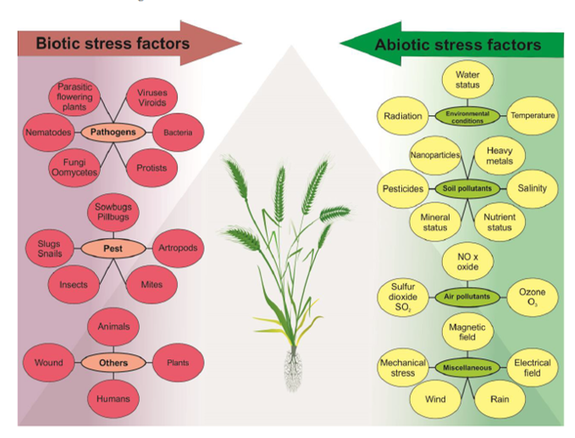
Figure 1. Explains how a variety of environmental elements may stress plants, including biotic ones like diseases, pests, and direct effects on people and animals, as well as abiotic ones like weather fluctuations, soil and air pollution, and magnetic fields. These stressors have the potential to upset a plant's homeostasis, stop it from growing, and have an impact on the growth of both developed field crops and wild populations. (Georgieva and Vassileva, 2023)

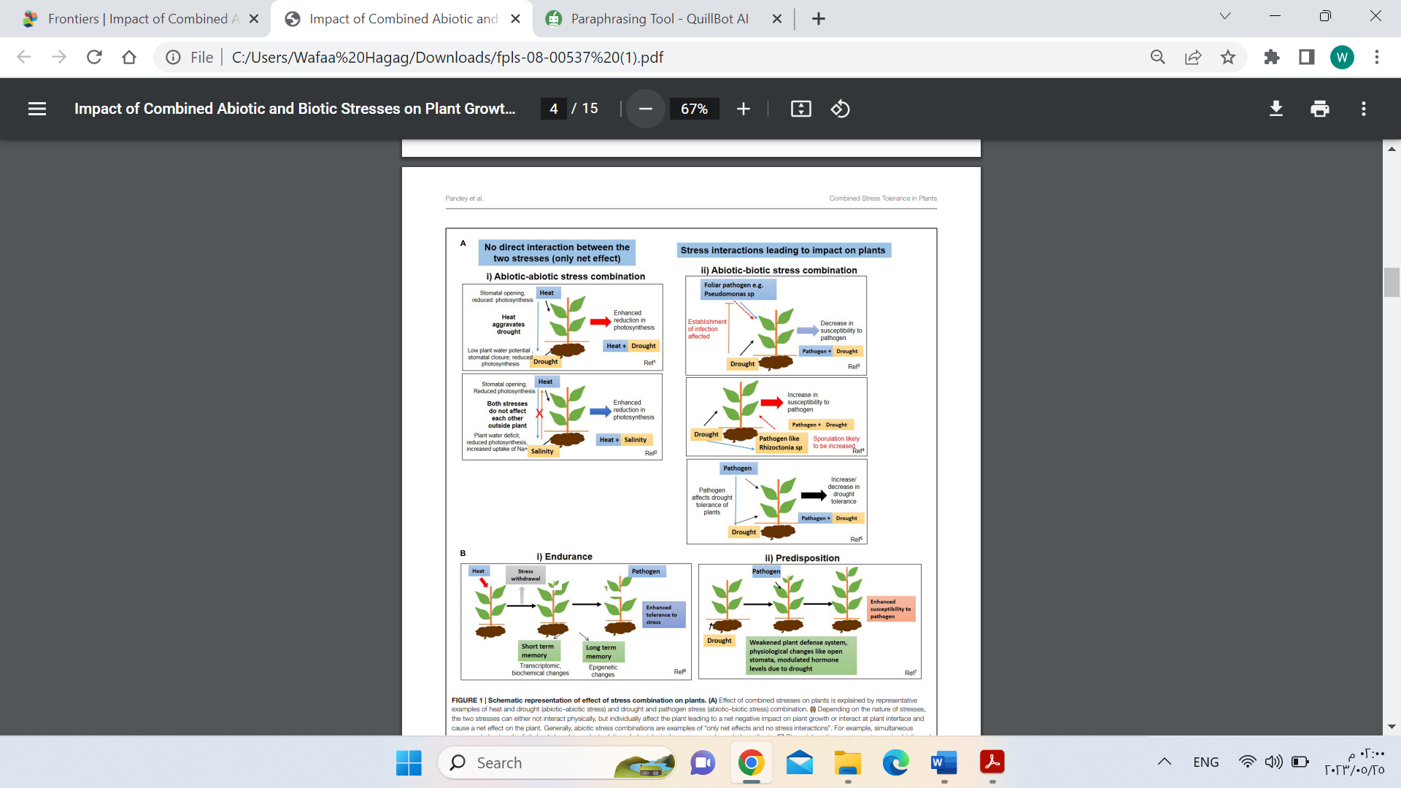Figure 2. An example of how stress and other factors work together to affect plants. (A) By utilising the examples of heat and drought (abiotic-abiotic stress) and drought and pathogen stress (abiotic-biotic stress), we can demonstrate how combined pressures affect plants. (i) Even if the two stresses do not come into physical touch with one another, they may interact at the plant-to-plant interface and negatively impact the plant as a whole, depending on the type of stressors. It is common to specify "only net effects and no stress interactions" in relation to abiotic stress combinations. For instance, prolonged exposure to salt and heat inhibits physiological processes such as photosynthesis. When one stress component influences another, there are evident stress interactions in both biotic and abiotic stress combinations (Mittler, 2006)

Strategies for biotic and abiotic stress management in plants

The methods for enhancing crop performance under stress and combination biotic and abiotic stresses have been discusses. The management strategy used by farmers and agronomists heavily incorporates plant stresses. Farming and agricultural research have led to a rise in the number of stressors studied. This implies that although the list of plant stressors might be long, knowledge of them can be beneficial to a farm's performance.

Plant tolerant

Plants experience significant biotic and abiotic stressors because they are sessile, unlike other living things. Plants have evolved a wide range of efficient defence mechanisms that are fueled by external factors like shock duration and intensity as well as inherent ones like developmental conditions and genotypic and phenotypic makeup. Stress management incorporates molecular and biochemical level controls that alter the speed and efficiency of a stress signal's interpretation and transmission, which in turn produces stress signal molecules and activates stress-protective mechanisms. Plant competence allows for a wide range of adaptive responses to biotic and abiotic stressors at the morphological, physiological, biochemical, and molecular levels. To increase plant productivity in challenging environments, genetic modifications of signalling networks have been frequently exploited. Agriculture may be sustained sustainably with the use of advanced biotechnology applications. Several metabolic and molecular pathways implicated in plant responses to varying environmental conditions have been identified and reported by recent study. As hundreds more metabolic pathways are discovered, it is becoming increasingly evident how polyamines help plants cope with stress and improve their ability to acclimatise and adapt. In this respect, Rangan et al., (2014) state a relevant overview of our understanding of polyamine production and catabolism and highlight recent advancements in clarifying the roles of polyamines in regulating plant responses to abiotic stressors. The improved stress tolerance might subsequently be achieved by using the genotypes that have suitable allelic variations.
According to Saddique et al. (2018), the intensity, and ability of plants to activate the appropriate defence mechanisms all affect how they react to biotic stress. Plants react to external stressors by initiating many hormonal pathways. The Jasmonic acid (JA) pathway plays a major role in plant defence against necrotrophic fungus and some bacterial infections. When these stressors exist, plants respond by producing JA, which initiates a cascade of signalling connections that ultimately lead to the activation of genes relevant to defence and the production of specialised metabolites including phytoalexins and protease inhibitors. (Saddique et al., 2018). Another important phytohormone that is essential for plant defence against biotic stress is salicylic acid (SA). Additionally, phytohormones like auxin, brassinosteroids, gibberellins, cytokinins, abscisic acid (ABA), and peptide hormones are also implicated in modifying plant immune responses (Saddique et al., 2018).
According to Ku et al. (2018), JA is one of them that interacts with other phytohormonal pathways and is important in activating the plant defence system.
In reaction to external stimuli, plant cells go through a variety of physiological changes. The quality of the harvested products may suffer as a result of these reactions, which might alter the phenology, growth, reproduction, and chemical composition of plants. However, the effects of various external stressors on plant development and physiological systems vary according to the stress's intensity, any concomitant stressors, the plant's genotype, and its growth stage. The primary effects of these pressures on plants' morphophysiological and biochemical traits are reductions in growth and yield. These consequences include decreased leaf area, changed root development, stomatal conductance, membrane instability, reduced photosynthetic activity, and altered oxidative metabolism and water relations. However, a plant's genetic makeup, ability to withstand stress, and a variety of environmental factors all affect how it responds to stress overall. Plant tissues and organs work together via chemical signals to adjust to adverse environmental circumstances. Stress sensing, signal transduction, and plant stress tolerance molecular networks are activated in a way that controls the expression of some stress-related genes and the production of stress-related enzymes. A significant part of the evolution of plants' stress tolerance mechanisms is also attributed to their increased antioxidant defence system.

Nutrients in stresses management

Potassium, sulphur, iron, manganese, zinc, and copper are the minerals that are most crucial for controlling plant stress. Plants need a healthy, balanced diet. Plants can absorb much more of these nutrients under stressful conditions. The proteins and enzymes produced by these nutrients are utilized to manage stress and control plant physiology. Under stresses plants can alter their physiological processes in an effort to boost nutrient intake by altering their root systems. This include modifying the angle of the roots, encouraging the formation of lateral roots or root hairs, or developing microbial connections with mycorrhizae. Foliar nutrients have been demonstrated to strengthen and advance root systems. In times of stress, "super-oxides" (complex oxygen compounds) can accumulate in the plant. Plants can produce antioxidants to combat this. Some of the essential minerals needed to produce these antioxidant enzymes, which aid in the plant's ability to cope with stress, are manganese, iron, copper, zinc, and sulphur.

Silicon

Numerous studies have examined the impact of silicon on biotic and abiotic stress, as well as overall plant growth and development. In both agriculture and the natural world, silica plays a critical and quantitatively important role in the soil-plant system (Epstein, 1994). It is only recently that Si's potential as a fertiliser for crop performance or as a plant protectant in an integrated disease/pest control approach is beginning to be commercially appreciated. This element is crucial to a plant's survival in numerous ways, but it is particularly effective in reducing biotic and abiotic stressors. With a few exceptions, the following generalisations regarding Si may now be drawn based on the research that has been done thus far: (1) For a plant disease to be suppressed, its tissues must contain a minimum amount of silicon (Si); (2) disease suppression will increase proportionately as the amount of Si in plant tissues increases; (3) the effects of disease suppression must be continuously supplied to the plant roots; and (4) only plants that have received this supply of silicon will be able to suppress disease. The physiological, biochemical, and molecular reactions of plants to pathogen infection, insect assault, and even abiotic stress will only alter when Si is delivered to the roots; (5) Si will impact several elements of host resistance, including the number of lesions, incubation time, and latent duration; (6) Si may boost a cultivar's resistance to foliar diseases in specific rice and sorghum cultivars; and (7) Si can suppress disease just as well as fungicides (Datnoff and Rodrigues, 2015). According to Fortunato et al. (2015), Fusarium wilt on cucumber and lettuce, Fusarium root rot on melon, Phytophthora root rot on avocado and soybean, and Phytophthora blight on bell pepper are the most important soilborne diseases that Si has been demonstrated to be able to manage. Pythium root rot can cause bitter gourds to become brown, maize to turn yellow and creeping bentgrass to develop brown patches and dollar spots due to Pythium root rot. When compared to the roots of non-supplied Si plants, the histochemical studies of banana plant root sections showed strong flavonoid deposition in the sclerenchyma and metaxylem vessels in response to F. oxysporum f. sp. cubense infection (Figure 3). (Fortunato et al.,2014).

Role of plant growth regulators in stresses tolerance

Organic substances known as plant growth regulators (PGRs) are substances that regulate different stages of plant growth and development. They are not nutrients. PGRs serve as secondary stress messengers, which they do to a significant extent in the mitigation of various abiotic stress situations. Five broad plant defense-related compounds that offer defence against abiotic stressors have been found by He et al. (2018). These include the cuticle, which serves as an outer barrier; suitable solutes; reactive species scavengers; unsaturated fatty acids (UFAs), which operate as a membrane modulator and oxylipin precursor; and molecular chaperones, which stabilise proteins and subcellular structures. Numerous upstream signalling molecules, such as phytochromes, calcium, reactive oxygen species, hydrogen sulphide, polyamines, reactive oxygen species, stress PHs, and transcription factors, are part of a complex regulatory network that controls these protective metabolites (He et al., 2018). Auxins, salicylates, ethylene, cytokinins, gibberellins, jasmonates and abscisic acid are among the nine categories of PHs that have currently been identified (Su et al., 2017).

Omics technologies

The study of biotic and abiotic stresses responses in plants has benefited greatly in recent years from the development of omics technologies (Ibraheem et al., 2018). Omics tools have greatly enhanced and protected crop quality, leading to higher agricultural food production, by improving the nutritional value, flavour, and quality of food crops. The time and expense needed to produce better food crops that are resistant to stress factors and exhibit a high nutritional value have decreased thanks to omics technologies such as genomics, transcriptomics, proteomics, metabolomics, and bioinformatics. This has made modern plant breeding more consistent and predictable (Ibraheem et al., 2018). Plants have developed a variety of physiological, metabolic, and biochemical defence mechanisms to withstand biotic and abiotic stresses. According to Chawla et al. (2011), plants have evolved complex signal transduction pathways for a variety of stress circumstances, but it is often difficult to predict when these pathways will become active or dormant. We are able to fully comprehend the structure and dynamic function of a molecular system thanks to the four main axes of plant system biology approaches: transcriptomics, proteomics, metabolomics, and genomics (Yuan et al., 2008). Compared to a single gene analysis, this approach provides a more comprehensive platform for researching biological processes as a complex network. The creation of new cultivars with improved stress tolerance is essential to controlling global climate change and meeting future food demands. Hence, regulating plant stress requires the integration of omics technologies.

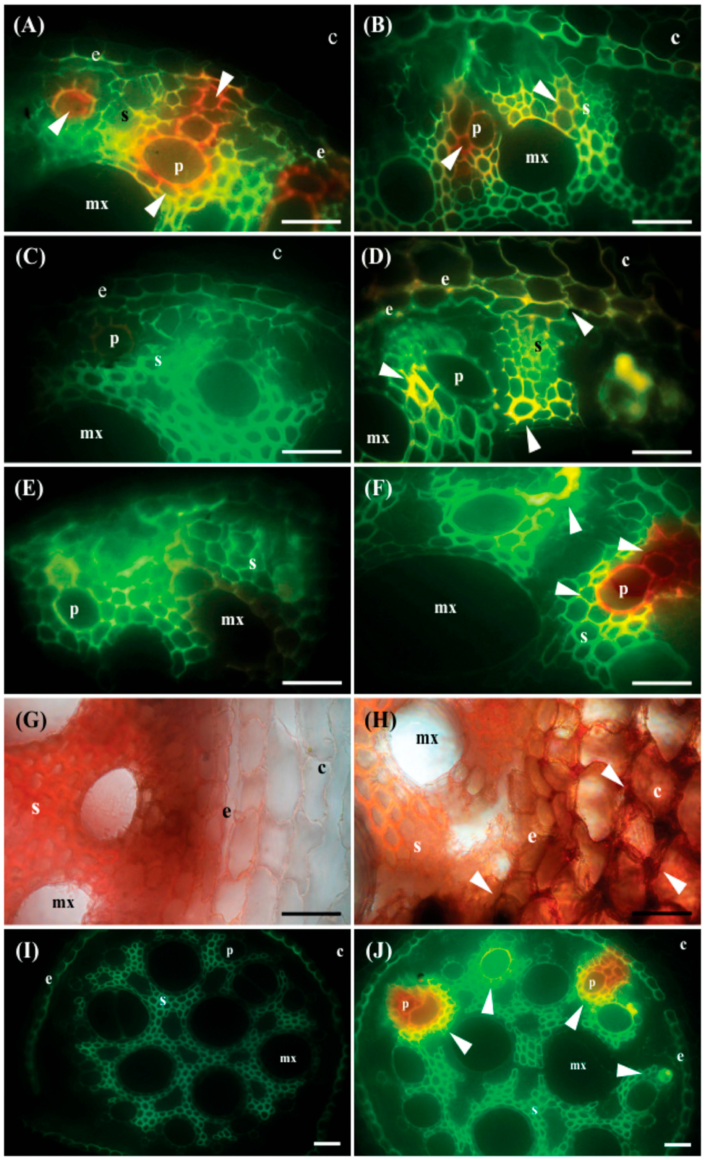
Figure 3. The presence of flavonoids, lignin, and dopamine in the roots of banana plants from the cultivar "Maç" were assessed by histochemical analysis 32 days following the plants' inoculation with Fusarium oxysporum f. sp. cubense. Vascular bundles and sclerenchyma cells in the roots of -Si plants exhibit strong yellow-orange autofluorescence (arrow). B, The phloem and metaxylem vessels in the roots of +Si plants have a modest yellow-orange autofluorescence (arrow). C,Neutron-stained roots of Si plants show no fluorescence in the vascular bundles, sclerenchyma, or endodermis cells. +The D, Neu's reagent-stained roots of Si plants exhibit a prominent yellow fluorescence (arrow). E, Transparent orange-yellow, reproduced with permission from Fortunato et al. (2014)

Microorganisms, bioelicitors and microbiome

Various microbial populations interact with plants, and they have intricate connections with one another. Plants are protected from a many biotic and abiotic obstacles thanks to the close relationship between microorganisms and their host. Symbiotic, parasitic, or mutualistic plant-microbe connections all revolve around plant-microbe interactions. By promoting natural processes, microorganisms provide plants their resistance to outside pressure. Biostimulants, bioelicitors also known as biofertilizers, are substances that assist plants recover from stress by increasing their tolerance to it against biotic and abiotic stresses (Haggag, 2016 and Haggag et al., 2017). Stronger plants result from the biostimulants that promotion of root growth and improved nutrition and water absorption.

The most efficient instrument that might be used to help agricultural plants develop their resistance to abiotic stimuli and contribute to adaptation techniques is microorganisms. The most efficient way that plant-growth promoting rhizobacteria (PGPR) reduce the effects of abiotic stressors (drought, low temperature, salt, and high temperatures) on plants is by producing production of bio films and exopolysaccharides (Chakraborty and Niharendu Saha, 2019). Since bacteria make up the majority of the microorganisms in soil, some of them that are observed colonizing plant roots are referred to as PGPR. The improvement of plant development under stressful situations has been linked to a variety of bacterial families. Research has demonstrated that PGPR, including Paenibacillus polymyxa, Achromobacter piechaudi, Azospirillum brasilense, Pseudomonas sp., Burkholderia and Bacillus, can improve the tolerance of drought in drought-stressed (Trivedi et al., 2020; Ali and Khan, 2021). According to Adedayo et al. (2022), microorganisms utilise biochemical and molecular pathways to help plants connect with bacteria in order to counteract the detrimental effects of abiotic stressors on plant growth. To change the way a plant's roots look, auxins, cytokinins, and gibberellins are some of the phytohormones that make a difference (Arkhipova et al., 2020), which alters how well plants adapt to environmental stresses like salinity, nutrient deficiency, heavy metal exposure, and drought. Hormones such as auxins are produced in response to stimulation of root cell elongation and lateral root formation. These processes improve the plants' capacity to take up water and nutrients. To lessen the negative consequences of abiotic stress, PGPR used induced systemic tolerance (IST), which comprises the following interventions. Examples of phytohormones include the synthesis of auxin, abscisic acid ( , and cytokinin; the degradation of the ethylene precursor; and the release of different antioxidants, including glutathione reductase andp eroxidase, which catalyse the transformation of oxidised glutathione into reduced glutathione through the ascorbate-glutathione cycle (Misra and Chauhan, 2020). Furthermore, plants' ability to adapt to a range of environments, including those that are vulnerable to abiotic stressors like salt, cold, drought, heat, toxic metals, and flooding, has been related to fungus (Poveda et al., 2020). Using bio elicitors like Acremonium coenophiulum, Streptomyces griseus, Trichoderma harzanium, T. viride, Rhodotorula glutinis, and Paenibacillus polymyxa and natural elicitors like methyl jasmonate, chitosan, ascorbic acid, and putrescein improved two wheat varieties, cvs. Gemmiza and Skaha, were able to withstand the stresses of an arid climate (Haggag et al., 2017). Endophytes and Arbuscular mycorrhiza are diverse communities of microorganisms that reside inside the host tissue without displaying any outward symptoms of infection and are involved in stress tolerance. However, they share many functional characteristics with other rhizospheric bacteria, including the ability to acquire nutrients, modulate phytohormones, synthesise bioactive chemicals, and produce antioxidant enzymes (Pathak et al., 2022). They are nevertheless superior to other microbes due to their greater capacity for colonisation and resistance to abiotic stress (Pathak et al., 2022). These fungi give stress tolerance by altering the host plant's physiological, biochemical, and nutritional traits. These include siderophore overproduction, proline buildup, sodium absorption inhibition via increased uptake of electrolytes like K, improved uptake of root water, and increased antioxidant capacity (Diagne et al., 2020). The endophytic strain has recently been used with effectiveness against biotic stress. It has been discovered that endophytes, such as Fusarium culmorum, Curvularia protuberata, Phoma glomerata, Penicillium sp., Paecilomyces formosus and Trichoderma, confer resilience against abiotic stimuli and stress (Haggag et al., 2017 and Okon et al., 2020). The endophytic bacterium Lactobacillus Plantarum has been shown by Chen et al., (2020) to have biocontrol capability both an in-vitro investigation and an in-vivo experiment on Botrytis cinerea's mycelial growth. The pathogen Monilinia fructigena was successfully controlled by Madbouly et al. (2020) using various endophytic yeast strains.
More in-depth research is required to determine whether and how selective breeding influences the microbiomes of contemporary industrial systems. Therefore, it is crucial to explain the origins of the related microorganisms as well as their species (Nevo, 2012). Future agricultural research will benefit greatly from a comprehensive knowledge of the plant-microbe connection, which includes the molecular processes, signal transduction, genetic foundation, and underlying gene activities. It is clear that concentrating on microbial-plant interactions can result in viable approaches to developing ecologically sustainable production systems and goods that enhance biotic and abiotic stress management, promote food quality, disease prevention, and plant health, as well as the restoration of soil health. Microbiome products, also called biostimulants or biofertilizers, are any material or microbe given to plants with the express purpose of enhancing feeding efficiency, abiotic stress tolerance, and/or crop quality features. Plant communities use their microbiomes to form and evolve.
Nanoparticles in plants stresses management

Nanoparticles, such as Zn NPs, Ag NPs, SiO2 NPs, Cu NPs, Fe NPs, Mn NPs, C NPs, Ti NPs, Ce NPs, and K NPs, were effective in reducing the detrimental effects of salt stress in a range of plants (Zulfiqar and Ashraf, 2021). Cerium-oxide nanoparticles have been shown to improve photosynthetic activity and improve mineral absorption by changing the root cells of Brassica napus (Khan et al., 2020). In addition to improving plant roots' hydraulic conductivity and water absorption to boost their resilience to drought stress, NPs show a differential abundance of proteins implicated in oxidation-reduction, ROS detoxification, stress signalling, and hormone pathways in plants (Kandhol et al., 2021). Examples of metal-oxide nanoparticles that have been shown to be effective in boosting the physiological and metabolic activities of plants under drought stress include iron oxide (Fe3O4), titanium dioxide (TiO2), and zinc oxide (ZnO) (Alabdallah et al., 2022). Along with nanofertilizers, it was shown that greenly synthesised Fe3O4 NPs were effective in reducing the effects of drought stress on fenugreek plants (Bishta et al., 2022).
Chitosan nanoparticles have been shown to be effective in lowering photosynthetic activity, electrolyte leakage, and membrane damage in chickpea plants subjected to cold stress via transcriptional regulation (Amini et al., 2017). Similar to this, SiNPs can enhance sugarcane plants' capacity for photosynthetic activity while they are under stress from cold (Elsheery et al., 2020). By using Fe3O4 NPs, the amount of Cd metal that is available in soil has been decreased (Wang et al., 2020). In plants, flooding stress has been shown to be reduced by nanoparticles. Similar to this, it was shown that Zn nanoparticles could improve wheat's resistance to heat stress by boosting the synthesis of antioxidant enzymes and lowering lipid peroxidation (Hassan et al., 2018).
Applications of nanosilica, generated from the algae Blue-green Cyanobacteria - Oscillatoria agardhii, improved wheat resilience to biotic stress, such as illnesses, environmental stress, and the quality of the soil and irrigation water ( Haggag et al. , 2018). Under normal circumstances, this led to a reduction in crop losses and an increase in agricultural yield in some semi-arid locations. Treatment with blue-green algae resulted in an increase in antioxidant enzymes such as catalase (CAT), peroxidase (POD), and superoxide dismutase (SOD). Additionally, there was a general rise in grain yield, flour protein, and glutamine, as well as an improvement in wheat yield quality indices.

Conclusion

The increasing need for food to support a growing population and the continued need for global food security prevent agricultural production from rising due to environmental pressures. These stresses have significantly harmed the global agri-cultural sector's economy in addition to reducing crop output. Plants have developed sophisticated defensive mechanisms to fend off environmental challenges and guarantee their survival in the face of a range of hardships (Grey and Brady, 2016). Modifying the structural features of plants to modify their morphology and anatomy might be a strategy to mitigate the consequences of climate change (Bano et al., 2019). One of the key jobs to preserve crop quality and profitability is reducing stress in plants. And achieving that sustainably is an even bigger problem. Plants can adapt to their environment by developing long-lasting resistance, transient resistance, or complete resistance to the stress. There are still ways to encourage plant development if crops haven't evolved to withstand severe conditions. Various approaches have been developed to mitigate these effects, ranging from traditional breeding at the whole-plant level to isolating and transferring resistant genes at the molecular level to enhance crop development. Despite the challenges in these techniques, a simple, low-cost method of using microorganisms has been viewed as a potential, broad-spectrum way of generating the necessary compounds. In particular, under various environmental challenges including infections, drought, and salinity, plant growth-promoting bacteria have several positive effects that can be targeted to maximise agricultural productivity.

Under stressful conditions, microorganisms, microbiome and bionanoproducts improved many plants' morphological characteristics, physio-biochemical and yield characteristics, including chlorophyll content, relative water content, enzyme activity, and grain yield. Understanding these interactions between microorganisms and plants using various molecular and biochemical strategies will enhance their capacity to manage stress. It may be more cost-effective and environmentally benign to use microbial inoculation to treat plant stressors since it would be available sooner.

The creation of crop simulation models that combine both biotic and abiotic challenges can help with disease predictions in locations where the two stressors frequently overlap. The effective creation of combination stress-resistant crops that can perform well under field circumstances requires collaboration between crop modelling specialists, agronomists, field pathologists, breeders, physiologists, and molecular biologists.

References

Adedayo, A. A., Babalola, O. O., Prigent-Combaret, C., Cruz, C., Stefan, M., Kutu, F. and et al. (2022). The application of plant growth-promoting rhizobacteria in Solanum lycopersicum production in the agricultural system: a review. PeerJ, 10:e13405. doi: 10.7717/peerj.13405

Alabdallah, N. M., Hasan, M., Hammami, I., Alghamdi, A. I., Alshehri, D. and Alatawi, H. A. (2021). Green Synthesized Metal Oxide Nanoparticles Mediate Growth Regulation and Physiology of Crop Plants under Drought Stress. Plants, 10:1730.

Ali, S. and Khan, N. (2021). Delineation of mechanistic approaches employed by plant growth promoting microorganisms for improving drought stress tolerance in plants. Microbiological Research, 249:126771.

Amini, S., Maali-Amiri, R., Mohammadi, R. and Shahandashti, S. S. K. (2017). cDNA-AFLP analysis of Transcripts Induced in Chickpea Plants by TiO2 Nanoparticles during Cold Stress. Plant Physiology and Biochemistry, 111:39-49.
Arkhipova, T., Martynenko, E., Sharipova, G., Kuzmina, L., Ivanov, I., Garipova, M. and Kudoyarova G. (2020). Effects of Plant Growth Promoting Rhizobacteria on the Content of Abscisic Acid and Salt Resistance of Wheat Plants. Plants, 9:1429.
Atafar, Z., Mesdaghinia, A., Nouri, J., Homaee, M., Yunesian, M., Ahmadi, M. and et al. (2009). Effect of fertilizer application on soil heavy metal concentration. Environmental Monitoring and Assessment, 160:83-8.
Bano, C., Amist, N. and Singh, N. B. (2019). Morphological and anatomical modifications of plants for environmental stresses. In Molecular Plant Abiotic Stress: Biology and Biotechnology, 1st ed.; Roychoudhury, A., Tripathi, D., Eds.; John Wiley & Sons, Ltd.: Hoboken, NJ, USA; pp.29-44.

Bishta, S., Sharma, V. and Kumari, N. (2022). Biosynthesized magnetite nanoparticles from Polyalthia longifolia leaves improve photosynthetic performance and yield of Trigonella foenum-graecum under drought stress. Plant Stress, 5, 100090.
Chakraborty, S. and Niharendu, S. (2019). Role of microorganisms in abiotic stress management International Journal of Science, Environment ISSN 2278-3687 (O) and Technology, 8:1028-1039.
Chawla, K., Barah, P., Kuiper, M. and Bones, A. M. (2011). Systems biology: a promising tool to study abiotic stress responses. In: Omics and plant abiotic stress tolerance. Bentham Science, Sharjah, pp.163-172.

Chen, C., Cao, Z., Li, J., Tao, C., Feng, Y. and Han, Y. A. (2020). Novel endophytic strain of Lactobacillus plantarum CM-3 with antagonistic activity against Botrytis cinerea on strawberry fruit. Biological control, 148:104306.

Coakley, S. M., Scherm, H. and Chakraborty, S. (1999). Climate change and plant disease management. The Annual Review of Phytopathology, 37:399-426.

Datnoff, L. E. and Rodrigues, F. A. (2015). Highlights and prospects for using silicon in the future. Pages 139-145 in: Silicon and Plant Diseases. F. A. Rodrigues and L. E. Datnoff, eds. Springer, Cham, Switzerland. https://doi.org/10.1007/978-3-319-22930-0_6 .
Diagne, N., Ngom, M., Djighaly, P. I., Fall, D., Hocher, V. and Svistoonoff, S. (2020). Roles of Arbuscular Mycorrhizal Fungi on Plant Growth and Performance: Importance in Biotic and Abiotic Stressed Regulation. Diversity, 12:370.
Elsheery, N. I., Sunoj, V., Wen, Y., Zhu, J., Muralidharan, G. and Cao, K. (2020). Foliar application of nanoparticles mitigates the chilling effect on photosynthesis and photoprotection in sugarcane. Plant Physiology and Biochemistry, 149:50-60.
Epstein, E. (1994). The anomaly of silicon in plant biology. The Proceedings of the National Academy of Sciences, 91:11-17.
Fahad, S., Bajwa, A. A., Nazir, U., Anjum, S. A., Farooq, A., Zohaib, A. and et al. (2017). Crop production under drought and heat stress: plant responses and management options. Frontiers in Plant Science, 29:01147.
Fortunato, A. A., da Silva, W. L. and Rodrigues, F. A. (2014). Phenylpropanoid pathway is potentiated by silicon in the roots of banana plants during the infection process of Fusarium oxysporum f. sp. cubense. Phytopathology, 104:597-603.
Fortunato, A. A., Rodrigues, F. A. and Datnoff, L. E. (2015). Silicon control of soil-borne and seed-borne diseases. Pages 53-66 in: Silicon and Plant Diseases. F. A. Rodrigues and L. E. Datnoff, eds. Springer, Cham, Switzerland.

Georgieva, M. and Vassileva, V. ( 2023). Stress Management in Plants: Examining Provisional and Unique Dose-Dependent Responses. International Journal of Molecular Sciences, 24:5105.
Gray, S. B. and Brady, S. M. (2016). Plant developmental responses to climate change. Developmental Biology, 419:64-77.
Grime, J. P. (1977). Evidence for the existence of three primary strategies in plants and its relevance toecological and evolutionary theory. The American Naturalist, 111:1169-1194.
Gull, A., Lone, A. A. and Wani, N. U. I. (2019). Biotic and abiotic stresses in plants. In: de Oliveira AB, editor. Abioticand Biotic Stress in Plants. IntechOpen, https://doi.org/10.5772/intechopen.85832.

Haggag, W. M., Tawfik, M. M., Abouziena, H. F., Abd El Wahed M. S. A. and Ali, R. R. (2017). Enhancing Wheat Production under Arid Climate Stresses using Bio-elicitors. Gesunde Pflanzen, 69:149-158.

Haggag, W. M. (2016). Use of blue-green algae (cyanobacteria) as biofungicides, biostimulants and improve wheat resistance to abiotic stress. International Journal of Pharma and Bio Sciences . International Journal of pharma and bio sciences, 7:272-279.
Haggag, W. M. (2018). Development and application of biotechnological products for sustainable corn and soybean production under stresses condition. International Journal of Agricultural Technology, 14:1209-1224.
Haggag, W. M. and Ali, R. R. (2019). Microorganisms for wheat improvement under biotic stress and dry climate. Agricultural Engineering International: CIGR Journal, 21:118-126.

Haggag, W. M., Hoballah, M. M. E. and Ali, R. R. (2018). Applications of Nano Biotechnological Microalgae Product for Improve Wheat Productivity in Semai Aird Areas. International Journal of Agricultural Technology, 14:675-692.
Hartmann, A., Berkowitz, O., Whelan, J. and Narsai, R. (2022). Cross-species transcriptomic analyses reveals common and opposite responses in Arabidopsis, rice and barley following oxidative stress and hormone treatment. BMC Plant Biology, 22:62.

Hassan, N. S., El Din, T. A. S., Hendawey, M. H., Borai, I. H. and Mahdi, A. A. (2018). Magnetite and zinc oxide nanoparticles alleviated heat stress in wheat plants. Current Nanomaterials, 3:32-43.
He, M., He, C. Q. and Ding, N. Z. (2018). Abiotic stresses: General defenses of land plants and chances for engineering multistress tolerance. Frontiers in Plant Science, 19:1171.
Ibraheem, O., Adigun, R. O. and Olatunji, I. T. (2018). Omics technologies in unraveling plant stress responses; using sorghum as a model crop, how far have we gone? Vegetos, 31:1-18.
Jones, R. A. C. (2021). Global plant virus disease pandemics and epidemics. Plants, 10:233.

Kandhol, N.,Jain, M. and Tripathi, D. K. (2022). Nanoparticles as potential hallmarks of drought stress tolerance in plants. Physiologia Plantarum, 174:e13665.

Khan, I., Raza, M. A., Awan, S. A., Shah, G. A., Rizwan, M., Ali, B., Tariq, R., Hassan, M. J., Alyemeni, M. N. and Brestic, M. et al. (2020). Amelioration of salt induced toxicity in pearl millet by seed priming with silver nanoparticles (AgNPs): The oxidative damage, antioxidant enzymes and ions uptake are major determinants of salt tolerant capacity. Plant Physiology and Biochemistry, 156:221-232.

Ku, Y. S., Sintaha, M., Cheung, M. Y. and Lam, H. M. (2018). Plant hormone signaling crosstalks between biotic and abiotic stress responses. International Journal of Molecular Sciences, 19:3206.

Liliane, T. N. and Charles, M. S. (2020). Factors affecting yield of crops. In: Amanullah, editor. Agronomy –Climate Change & Food Security. IntechOpen; DOI: 10.5772/intechopen.90672. Retrieved from: https://www.intechopen.com/chapters/70658

Madbouly, A. K., Elyousr, K. A. A. and Ismail, I. M. (2020). Biocontrol of causal agent of brown rot of apple fruit, by using endophytic yeasts. Biological control, 144:104239.
Misra S. and Chauhan P. S. (2020). Deaminase-producing rhizosphere competent Bacillus spp. mitigate salt stress and promote Zea mays growth by modulating ethylene metabolism. Biotech, 10:119.

Mittler, R. (2006). Abiotic stress, the field environment and stress combination. Trends in Plant Science, 11:15-19. doi: 10.1016/j.tplants.2005. 11.002

Nevo, E. (2012). “Evolution Canyon,” a potential microscale monitor of global warming across life. The Proceedings of the National Academy of Sciences USA, 109:2960-2965.
Okon, O., Matrood, A. and Okon, J. (2020). Na exclusion and Na/K ratio adjustment by mycorrhiza enhances macro/micro nutrients uptake in two members of Cucurbitaceae family undersalt stress. International Journal of Botany Studies, 5:108-114.
Pathak, P., Rai, V. K., Can, H., Singh, S. K., Kumar, D., Bhardwaj, N., Roychowdhury, R., de Azevedo, L. C. B., Kaushalendra., Verma, H. and Kumar, A. (2022). Plant-Endophyte Interaction during Biotic Stress Management. Plants, 11:2203.

Pautasso, M., Döring, T. F., Garbelotto, M., Pellis, L. and Jeger, M. J. (2012). Impacts of climate change on plant diseases–opinions and trends. European Journal of Plant Pathology. 133: 295-313.
Poveda, J., Abril-Urias, P. and Escobar, C. (2020). Biological Control of Plant-Parasitic Nematodes by Filamentous Fungi Inducers of Resistance: Trichoderma, Mycorrhizal and Endophytic Fungi. Frontiers in Microbiology, 11:992.

Rangan, P., Subramani, R., Kumar, R., Singh, A. K. and Singh, R. (2014). Recent advances in polyamine metabolism and abiotic stress tolerance. BioMed Research International, 239621.
Rauwane, M. and Ntushelo, K. (2020). Understanding biotic stress and hormone signalling in cassava (Manhotesculenta): Potential for using hyphenated analytical techniques. Applied Sciences, 20:8152.

Saddique, M. and Kamran, M. (2018). Shahbaz, M. Differential responses of plants to biotic stress and the role of metabolites. In Plant Metabolites and Regulation under Environmental Stress; Academic Press: Cambridge, MA, USA, pp.69-87.

Saijo, Y. and Loo, E. P. I. (2020). Plant immunity in signal integration between biotic and abiotic stress responses. New Phytologist 2020, 225:87-104.

Scheffers, B. R., De Meester, L., Bridge, T. C., Hoffmann, A. A., Pandolfi, J. M., Corlett, R. T., Butchart, S. H., Pearce-Kelly, P., Kovacs, K. M. and Dudgeon, D. and et al. (2016). The broad footprint of climate change from genes to biomes to people. Science, 354:aaf7671.

Sharma, M. and Pande, S. (2013). Unravelling effects of temperature and soil moisture stress response on development of dry root rot [Rhizoctonia bataticola (Taub.)] Butler in Chickpea. American Journal of Plant Sciences4, 584-589.
Su, Y. i, Xia, S., Wang, R. and Xiao, L. (2017). Phytohormonal quantification based on biological principles. Hormone Metabol. Signal. Plants, 431-470.

Suzuki, N., Rivero, R. M., Shulaev, V., Blumwald, E. and Mittler, R. (2014). Abiotic and biotic stress combinations. New Phytologist, 203:32-43.

Trivedi P., Leach J. E., Tringe S. G., Sa, T. and Singh, B. K. (2020). Plant–microbiome interactions: From community assembly to plant health. Nature Reviews Microbiology,18:607–621.doi: 10.1038/s41579-020-0412-1.

Wang, Y., Liu, Y., Zhan, W., Zheng, K., Lian, M., Zhang, C., Ruan, X. and Li, T. (2020). Long-term stabilization of Cd in agricultural soil using mercapto-functionalized nano-silica (MPTS/nano-silica): A three-year field study. Ecotoxicology and Environmental Safety, 197:110600.
Yuan, J. S., Galbraith, D. W., Dai, S. Y., Griffin, P. and Stewart, C. N. Jr. (2008). Plant systems biology comes of age. Trends in Plant Science, 13:165-171.

Zulfiqar, F. and Ashraf, M. (2021). Nanoparticles potentially mediate salt stress tolerance in plants. Plant Physiology and Biochemistry, 160:257-268.

(Received: 11 June 2023, Revised: 31 December 2023, Accepted: 1 January 2024)

∗Corresponding Author: Haggag, W. M.; Email: wafaa_haggag@yahoo.com

