**Impacts of artificial shading on growth and some morphological traits of Romaine lettuce (*Lactuca sativa* L. cv. Romaine) cultivated in urban areas**

**Lakitan, B.1,2[1], Fhadilah, N.1, Muda, S. A.1, Irmawati1, Ria, R. P.1, Ramadhani, F.1, Ratmini, N. P. S.3, Gustiar, F.1, Nurshanti, D. F.4 and Rizar, F. F.1**

1College of Agriculture, Universitas Sriwijaya, Inderalaya 30662, Indonesia; 2Research Center for Sub-optimal Lands, Universitas Sriwijaya, Palembang 30139, Indonesia; 3National Research and Innovation Agency, Palembang 30137, Indonesia; 4College of Agriculture, Universitas Baturaja, Baturaja 32115, Indonesia.

Lakitan, B., Fhadilah, N., Muda, S. A., Irmawati, Ria, R. P., Ramadhani, F., Ratmini, N. P. S., Gustiar, F., Nurshanti, D. F. and Rizar, F. F. (2025). Impacts of artificial shading on growth and some morphological traits of Romaine lettuce (*Lactuca sativa* L. cv. Romaine) cultivated in urban areas. Journal of Agricultural Technology 21(4):1329-1346.

**Abstract** Shade has an impact on the leaf morphology of Romaine lettuces. The shape of the leaves that grow below 80% shade was slimmer and elongated. The effect of etiolation was also clearly visible on the plant canopy at 80% shade. The main stem became slimmer and taller. Dense shade (80%) was proven to inhibit the enlargement process (0.662 cm2/day) and the final size of the leaf area. Also, the leaves became stagnant earlier (7.92 days). The leaf length (L) x leaf width (W) was selected as a predictor in estimating the leaf area (LA). The most reliable model for LA estimation is using a linear regression model with zero intercept LA = 0.6907 LW (R2 = 0.9851). Morphologically, the growth of Romaine lettuces was also hampered in the canopy area, canopy diameter, number of leaves, leaf thickness, main stem length, leaf length, and leaf width. On the other hand, the growth of Romaine lettuces that were exposed to full sunlight increased the weights of stem, leaf and roots. There was a strong positive relationship between the leaf area and some selected parameters such as leaf fresh weight, leaf dry weight, petiole fresh weight, and petiole dry weight. It is concluded that Romaine lettuce is found to be a type of vegetable that showed intolerant of shade. It is needed additional artificial light to achieve good crop yields and vegetable quality under shady enviroment.

**Keywords:** Artificial lighting, Leaf area estimation, Olericulture, Tropical vegetable

**Introduction**

According to FAO, up to 70% of the world's food supply is consumed by urban inhabitants, who make up 55% of the global population (FAO, 2019). Thus, a greater effort is needed to enhance food supply in urban areas due to the large proportion of the urban population and the rising food demand. Subsequently, urban farming was seen as one of the solutions to this issue. Urban farming refers to the technique of growing crops in urban environments by using the limited space available, which may involve the use of hydroponics and vertical farming systems (Gumisiriza *et al.*, 2022; 2023; Sandison *et al.*, 2023; Wicharuck *et al.*, 2023).

Romaine lettuce (*Lactuca sativa* L.) is one of the leafy vegetables whitin the Asteraceae family that is considered to have many benefits, especially in terms of fulfilling human nutrition. In general, lettuce has low contents of calories, fat, and sodium while being high in vitamin C, iron, fiber, and folate (Kim *et al.*, 2016a). Romaine lettuce was reported to have higher insoluble fiber and nutritional content compared to other lettuce varieties (Kim *et al.*, 2016b). Given its high nutritional value, romaine lettuce is suitable as a homegrown vegetable crop to provide for the food needs of urban households.

Although it thrives in cool weather, romaine lettuce can withstand moderate temperatures without bolting and is reported to have a relatively tolerance for heat (Holmes *et al.*, 2019). However, due to being surrounded by tall buildings, one of the constraints on urban farming is the inadequate sunshine that lettuce plants may receive. Reduced solar interception will impact the rate of photosynthetic energy production, resulting in decreased productivity and lower-quality products, which would increase economic losses (Cometti *et al.,* 2020). Accordingly, an attempt is needed to determine the lettuce plant tolerance to shading by assessing the growth of romaine lettuce plants under various shading intensities. Though the effects of shade on lettuce have been documented in a number of studies (Alves *et al.*, 2022; Hassanien and Ming, 2017), there is still limited information regarding the morphological performance of romaine lettuce under shading environment.

Furthermore, it is also crucial to carefully consider when the seedlings should be transplanted to the new planting substrates. Proper transplanting at the right time can promote plant adaptability, leading to better development of plants. Delayed transplanting, on the other hand, prevent plants from growing to their full potential (Ahmad *et al*., 2024) due to early aging and reach the generative stage earlier, i.e. the plant starts to flower earlier and stops producing the appetizing leaves.

Few studies have been conducted on the effects of shade intensity and transplanting times, particularly on romaine lettuce. Thus, this study was carried out to evaluate the growth of romaine lettuce under different shading intensities and transplanting times.

**Materials and methods**

***Research site and agroclimatic condition***

The research was carried out at Jakabaring Research Facility, Palembang, South Sumatra, Indonesia. The research started in May and ended in August 2023. The research location is a tropical urban ecosystem with agroclimatic characteristics as represented in Figure 1.

**Figure 1.** Daily rainfall and relative humidity during the research was conducted Source: Indonesian Agency for Meteorology, Climatology and Geophysics

***Research protocols***

The study used romaine lettuce seed obtained from a commercial source. The seed was sown in seedling trays with topsoil as the seeding medium. Then, the seed was transplanted to pots measuring 27.5 cm (height) x 20 cm (diameter) filled with topsoil. The planting substrate was incubated for one week before transplanting. The substrate was applied with a bio-sterilization (2 g/l) with a dosage of 250 ml/pot containing *Streptomyces thermovulgaris*, *Trichoderma virens*, and *Geobacillus thermocatenulatus*. Transplanting time was adjusted according to the treatments, i.e., 10, 15, and 20 days after seed sowing (DAS), coded as T1, T2, and T3, respectively.

Transplanted romaine lettuce plants were exposed to artificial shading within three different shade-houses, according to shading intensity treatments, i.e., no shading (S0), 45% shading (S45), 55% shading (S55), and 80% shading (S80). Size of the shade house is 4.0 m (length) x 2.0 m (width) x 2.0 m (height), constructed using 1.5 inches PVC pipe and shading treatments using black polyethylene net.

The plant was fertilized at 2 weeks after planting (WAP) using NPK fertilizer (16:16:16) with a dosage of 3 g/plant. Meanwhile, watering was done twice every day in early morning 7.00 am and late afternoon at 5.00 pm. In rainy days, the plants were not watered.

***Data collection***

Selective leaves were tagged for studying leaf growth rate by non-destructively measuring leaf length, leaf width, leaf area, and leaf length/width ratio of each individual tagged leaves every days. Individual plant growth rate was weekly measured on canopy area, canopy diameter, leaf number per plant, leaf thickness, petiole length, and plant height. Healthy growth of plants was proxied by measuring the SPAD value (Konica Minolta, SPAD-502 Plus).

Destructive measurement was conducted 35 days after planting (DAP) to obtain fresh weight of marketable and non-marketable yield, fresh weight and dry weight of each plant organ, and leaf area estimation. Meanwhile, data collection related to the recovery of romaine lettuce after shading stress was carried out when the plants flowered. Data collected consisted of flowering time, internode length, leaf number, leaf length/width ratio, stem length, fresh weight marketable and non-marketable yield, and fresh weight and dry weight of each plant organ.

Leaf area estimation was done to find the most reliable regression equation between the selected predictors and the direct measuremen of leaf area obtained from the image scanner. The image scanner software used was LIA-32 for windows 10 (Kazukiyo Yamamoto, Nagoya University, Japan). Leaf SPAD value was obtained using a chlorophyll meter (Konica Minolta, SPAD-502 Plus) at 3 WAP. Meanwhile, to obtain dry weight, each plant organ was dried in oven at 100°C for 24 hours.

***Experimental design and statistical analysis***

The split-plot design was used in the Analisis of Variance. Shading intensity was designated as the main plot, while transplanting time was the sub-plot. Each treatment used 3 replications. All data collected were analyzed for variance, the level of significance between treatments was tested using the least significant difference (LSD) at P<0.05. The strength of relationship between variables were analyzed using some regression types, inluding linear, exponential, logarithmic, quadratic, power, linear with zero-intercept, and quadratic with zero-intercept. The analysis was performed using Rstudio (v2023.06.0+421) for windows 10.

**Results**

The lengthening and widening processes of the leaf blades in Romaine lettuce took place whitin 14 days. The leaf blade stopped enlarging after 14 days. The rate of acceleration and elongation of leaf blades was not hampered at 45% shade, yet the widening process was noticeably affected (Figure 2).

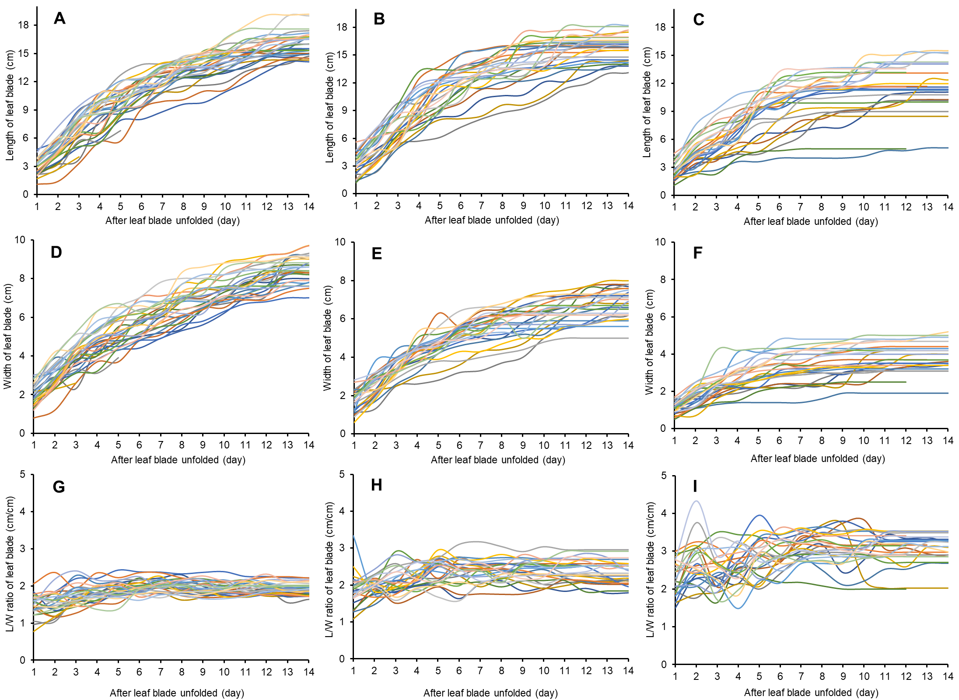

**Figure 2**. Leaf elongation (L), widening (W), and the L/W ratio in lettuce leaves of the Romaine cultivar exposed to full sunlight (A-D-G), 45% shade (B-E-H), and 80% shade (C-F-I)

Moreover, at 80% shade, the leaf enlargement process was noticeably shorter, the maximum size of leaf was smaller compared to leaves exposed to full sunlight. The influence of shading was more noticeable on the development of leaf width. A moderate shade intensity at 45% slowed down the widening process of Romaine lettuce leaves. Meanwhile, a higher shade intensity (80%) caused Romaine lettuce leaves to become slimmer as indicated by an increase in the L/W ratio.

The L/W ratio is lower in plants that receive full sun than in plants that experience shade. The higher shade intensity caused the higher L/W ratio. Visually, the higher L/W ratio caused slimmer leaves. Meanwhile, the difference in seedling ages at transplanting did not have a significant effect on the L/W ratio (Figure 3).

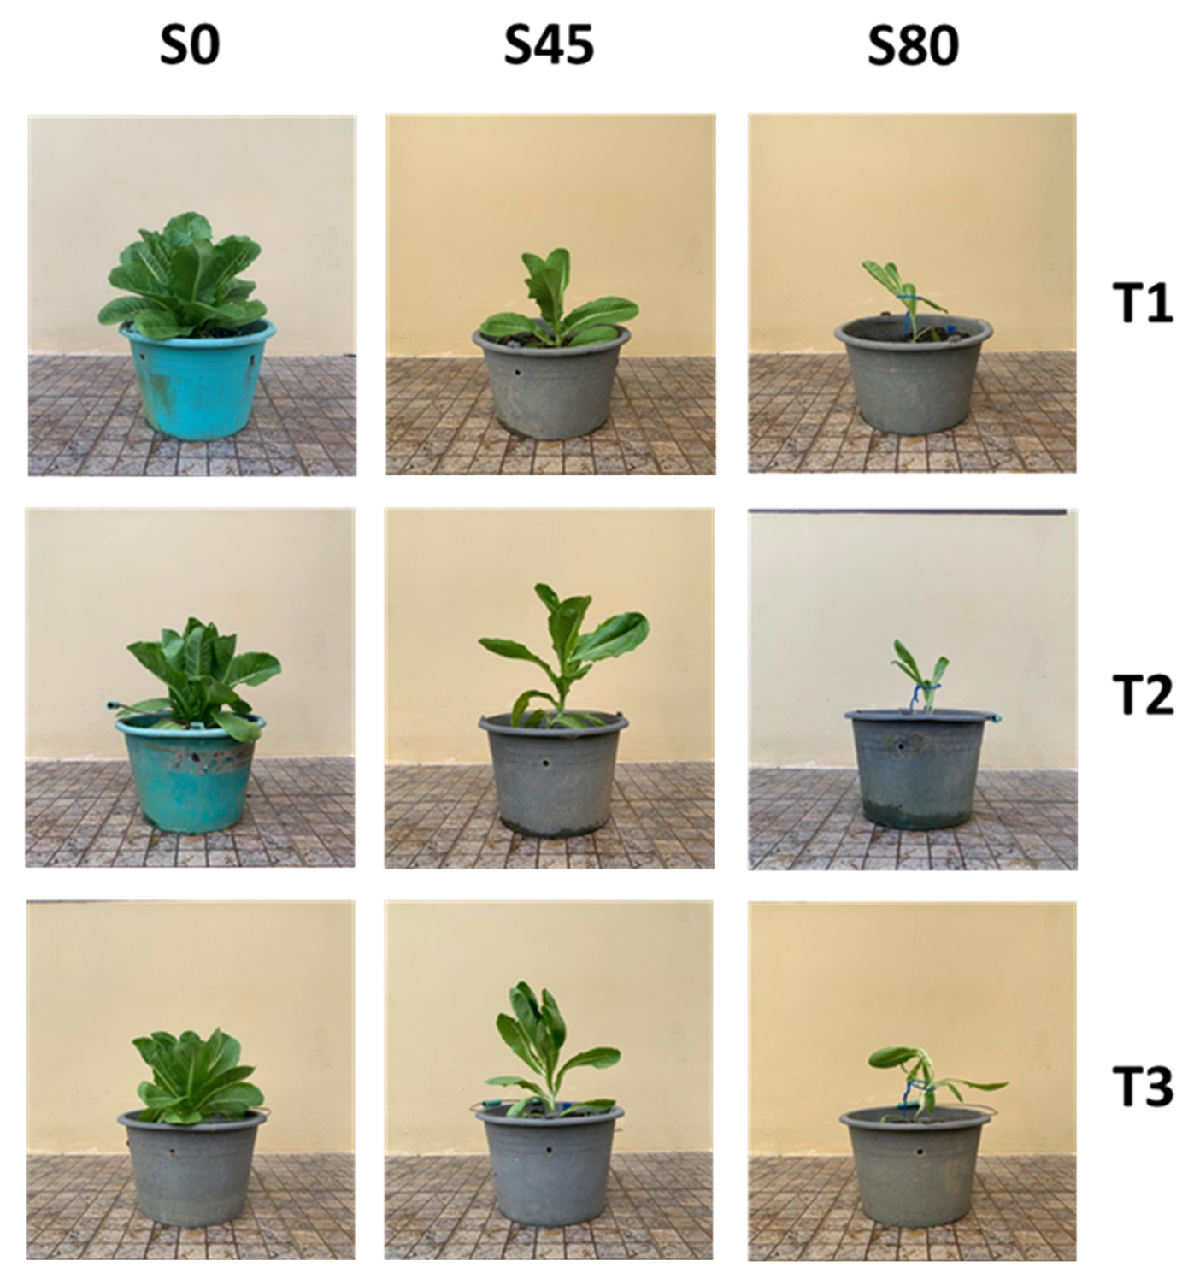

**Figure 3**. Visualization of the effect of shade 45% (S45) and 80% (S80) compared to plants receiving full sunlight (S0)

Amongst seven regression models that had been evaluated using three selected predictors, the zero-intercept linear model and LW as predictor shows the highest accuracy, as indicated by higher (0.9851) coefficient of determination (R2). The recommended leaf area estimation model is LA = 0.6907 LW (Table 1).

**Table 1**. Non-destructive leaf area estimation of Romaine lettuce using regression models on each morphological trait as predictors

|  |  |  |  |
| --- | --- | --- | --- |
| Predictor | Regression type | Model | R2 |
| Leaf length (L) | Linear | y=10.775L–80.622 | 0.8007 |
| Exponential | y=2.7182e0.2114L | 0.8499 |
| Logarithmic | y=117.87ln(L)-233.41 | 0.6948 |
| Quadratic | y=0.76092L2-9.007L+35.089 | 0.8655 |
| Power | y=0.0892L2.4693 | 0.8620 |
| Zero-intercept linear | y=571.8L | 0.9193 |
| Zero-intercept quadratic | y=0.5636L2-3.5577L | 0.8606 |
| Leaf width (W) | Linear | y=16.189W-37.951 | 0.9123 |
| Exponential | y=7.7349e0.2896W | 0.8425 |
| Logarithmic | y=90.504ln(W)-92.245 | 0.8299 |
| Quadratic | y=0.6039W2+7.9978W-14.205 | 0.9209 |
| Power | y=2.2384W1.7584 | 0.9190 |
| Zero-intercept linear | y=11.601W | 0.9645 |
| Zero-intercept quadratic | y=0.8883W2+3.7743W | 0.9188 |
| Leaf length (L) × leaf width (W) | Linear | y=0.7272LW-5.3462 | 0.9315 |
| Exponential | y=14.383e0.0127LW | 0.8289 |
| Logarithmic | y=52.556ln(LW)-159.83 | 0.7917 |
| Quadratic | y=0.0005LW2+0.6218LW-1.042 | 0.9329 |
| Power | y=0.5213LW1.0524 | 0.9326 |
| Zero-intercept linear | y=0.6907LW | 0.9851 |
| Zero-intercept quadratic | y=0.0005LW2+0.604LW | 0.9328 |

Estimation of leaf area is needed so that the same individual leaf can be continuously measured from the beginning of the leaf unfolded until the leaf reaches its maximum size. The predictors used are morphological traits whose measurement can be done non-destructively, such as the length, width, and thickness of leaves. However, leaf thickness does not correlate with leaf area. The morphological traits used in this study are midrib length or leaf length (L), leaf width (W), and multiplication between the length and width (LW). The leaf width is measured based on the widest distance of the leaves on a line perpendicular to the midrib.

Using the selected leaf area estimation model, a zero-intercept linear regression model with LA = 0.6907 LW, leaf development rates were obtained for plants that received full sun, 45% shade, and 80% shade. The rate of enlargement, the time span of leaves stops enlarging, and the maximum leaf size were markedly inhibited in Romaine lettuce plants with 45% shade and this inhibition was stronger at 80% shade (Figure 4).

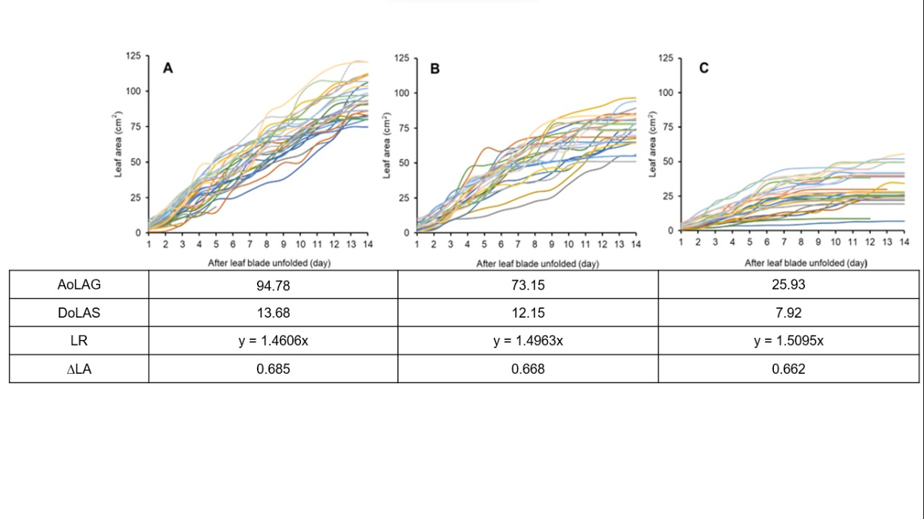

**Figure 4**. Leaf area of the Romaine cultivar lettuce exposed to full sunlight (A), 45% shade (B), and 80% shade (C); measured daily up to 14 days started at time the leaf bud was still unfolded. AoLAG = average of leaf area growth, DoLAS = number of days the leaves stop growing, LR= linear regression, ∆LA= leaf area increases per day

The regression line was developed based on the zero-intercept linear regression model and the LW as predictors. Measurements were taken consecutively daily for 14 days from the moment leaf buds began to unfold until the leaves began to stop enlarging in plants that received full sun. The final size of Romaine lettuce leaf blades exposed to shade (45%) for up to 14 days was shown to be smaller than that of lettuce leaves that received full light; furthermore, leaf enlargement was more severely halted for plants exposed to higher shade (80%). Interestingly, leaf growth inhibition occurred in two folds, i.e., the enlargement rate slowed down and the enlargement process stopped earlier for plants that experienced higher shading (Figure 4).

At the canopy level, the growth retardation due to the influence of shade on the Romaine lettuce plants were obvious, as shown on the decrease of horizontal canopy diameter and canopy area. While the delay in transplanting Romaine lettuce seedlings from the age of 10 days to 15 or 20 days did not show a significant effect (Figure 5).

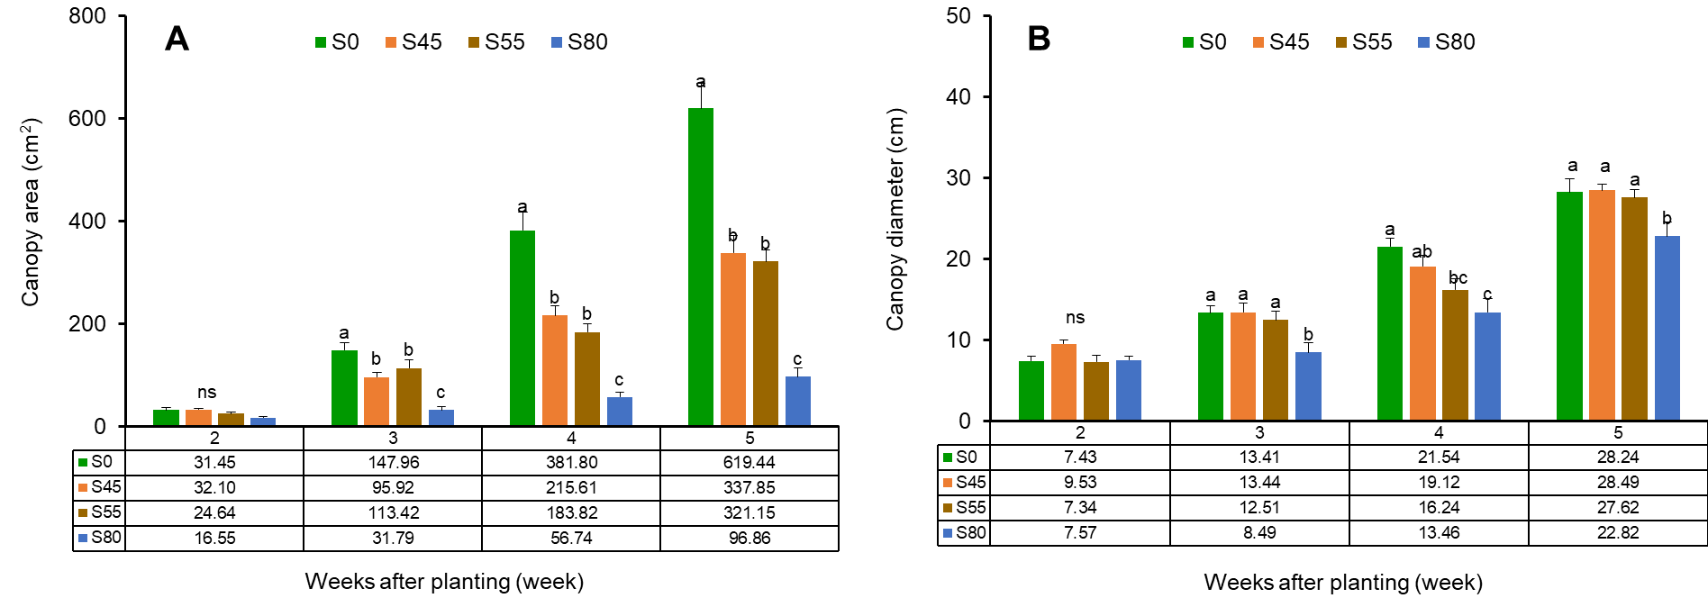

**Figure 5**. The effect of shade intensity on the diameter and area of the Romaine lettuce canopy

Shade at an intensity of 45% to 80% caused alterations in the morphological shape of Romaine lettuce plants, including elongation of the main stem (A) and petioles (B), followed by reduction in the cumulative number of fresh leaves at harvest (C), thickness of leaf blade (D), length of leaf midrib (E), and width of leaf blade (F). The elongation or the reduction of the morphological shape was especially visible when the plants reached 3 weeks old or older (Figure 6).

Although shade does not directly affect the growth and development of roots since this organ is entirely stored within the growing medium. Nevertheless, inhibition on growth of above-ground organs will also reduce the availability of nutrients and energy needed for roots to grow. In addition to inhibiting the growth of stems and leaves, indirectly the shade also inhibits root growth, as evidenced by the decrease in fresh weight and dry weight of Romaine lettuce plants (Tabel 2).

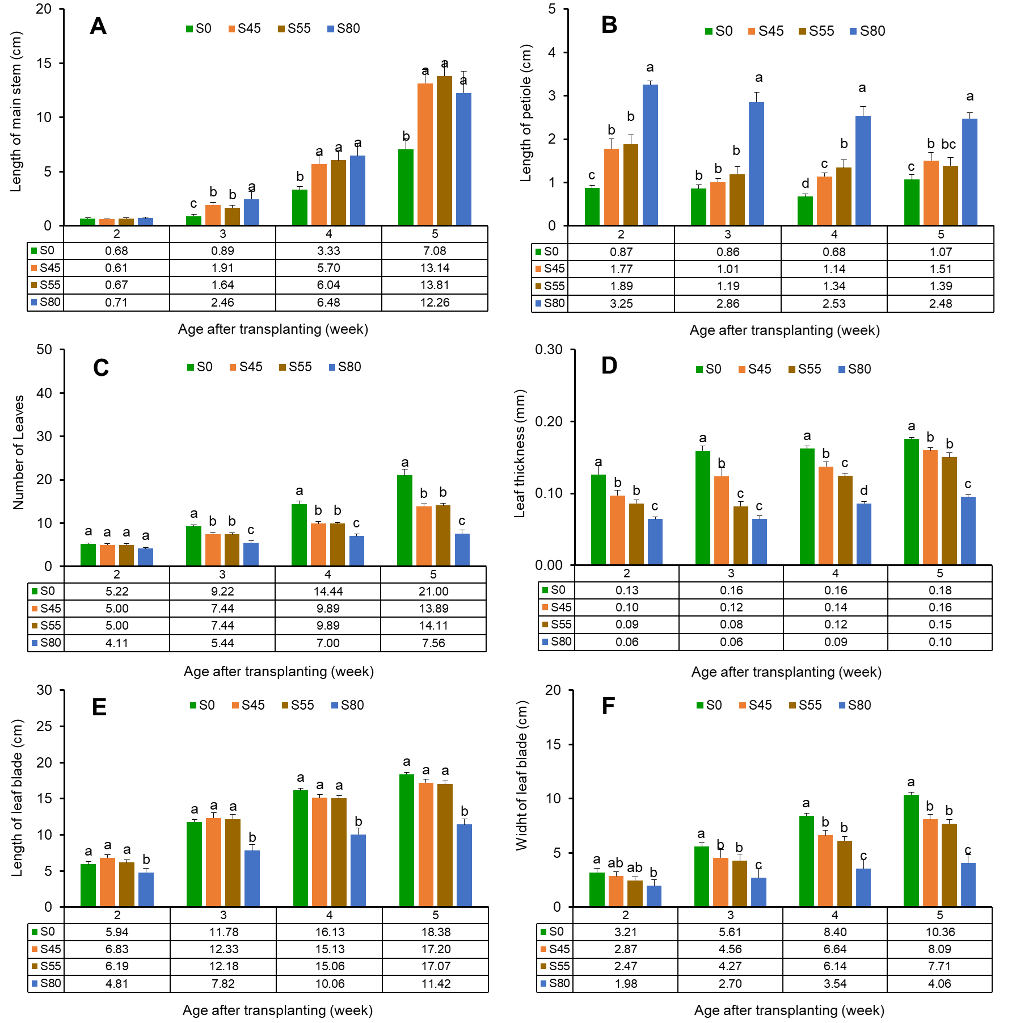

**Figure 6**. The impact of shade at an intensity of 45-80 percent on the morphological shape in the Romaine lettuce plants

Some traits had shown to be closely related to leaf blade area, especially to the fresh weight and dry weight of the leaf blade itself (A and B), i.e., leaf area can be predicted based on leaf weight. These relationships were also detected with the wet weight and dry weight of the petiole (C and D) although they were relatively weaker when compared to the closeness of the leaf blade area with both their fresh and dry weight. The thickness of the leaf blade in fresh conditions was also moderately related to leaf blade area (E). An interesting point was that petiole length was inversely proportional to leaf blade area, i.e., larger leaves tend to have shorter petioles on Romaine lettuce (F) (Figure 7).

**Table 2**. Decrease in fresh and dry weight of leaves, stems, and roots resulting from the impact of shading exposure on Romaine lettuce plants

|  |  |  |  |  |  |  |  |  |  |  |  |  |
| --- | --- | --- | --- | --- | --- | --- | --- | --- | --- | --- | --- | --- |
| **Treatment** | **Leaf** | | | | **Stem** | | | | **Roots** | | | |
|  | *Fresh weight* | | | | | | | | | | | |
| Full light | 64.20 | ± | 7.066 | a | 18.72 | ± | 1.423 | a | 7.420 | ± | 0.711 | a |
| 45% shade | 18.82 | ± | 1.845 | b | 9.26 | ± | 1.068 | b | 2.306 | ± | 0.164 | b |
| 55% shade | 16.69 | ± | 2.046 | b | 7.22 | ± | 0.397 | b | 1.947 | ± | 0.195 | b |
| 80% shade | 2.05 | ± | 0.356 | b | 1.39 | ± | 0.273 | c | 0.345 | ± | 0.053 | c |
| Significance | *** | | | | *** | | | | *** | | | |
| P-Value | 0.0005 | | | | 0.0002 | | | | 5.588 | | | |
| LSD-value | 17.36 | | | | 3.990 | | | | 0.884 | | | |
|  | *Dry weight* | | | | | | | | | | | |
| Full light | 6.536 | ± | 0.800 | a | 0.992 | ± | 0.087 | a | 0.692 | ± | 0.137 | a |
| 45% shade | 4.250 | ± | 0.781 | ab | 0.438 | ± | 0.045 | b | 0.142 | ± | 0.011 | b |
| 55% shade | 4.006 | ± | 1.002 | bc | 0.348 | ± | 0.020 | b | 0.124 | ± | 0.010 | b |
| 80% shade | 1.694 | ± | 0.233 | c | 0.060 | ± | 0.013 | c | 0.124 | ± | 0.007 | b |
| Significance | ** | | | | *** | | | | ** | | | |
| P-value | 0.004 | | | | ≤0.001 | | | | 0.004 | | | |
| LSD-value | 0.286 | | | | 0.236 | | | | 0.286 | | | |

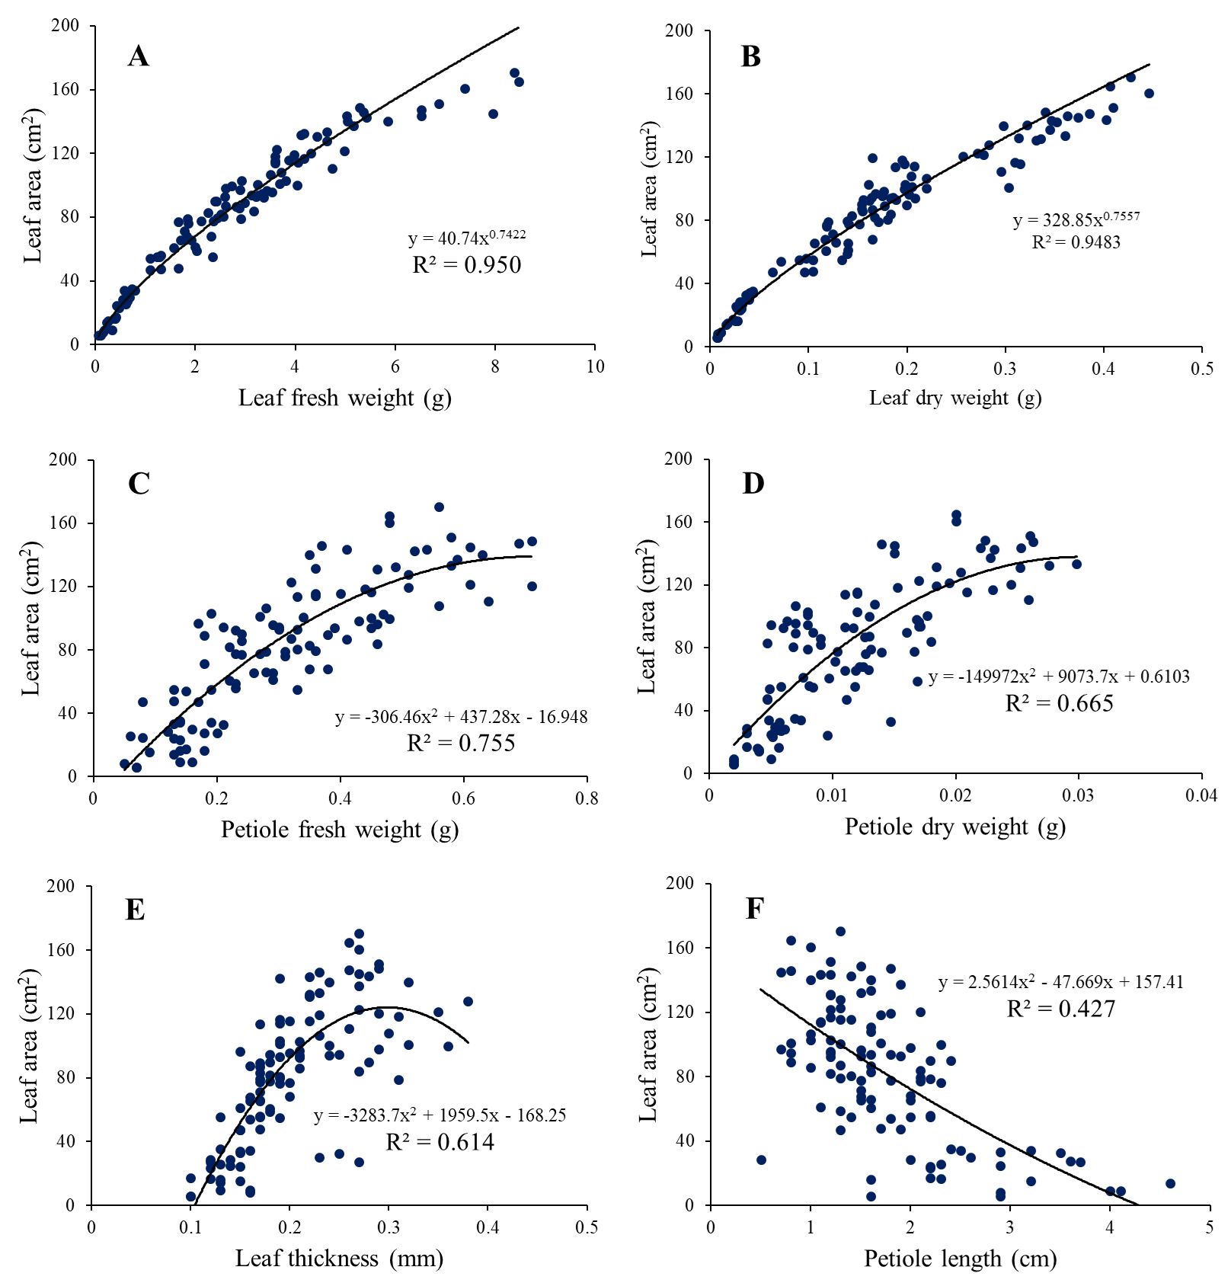

**Figure 7**. Relations amongst several weight-based and morphological traits with the leaf blade area of Romaine lettuce

**Discussion**

***Shade inhibits growth and stimulates deformation of leaves***

Shade directly lowers the intensity of sunlight at the position underneath the screen or at the opposite side of the source of light. Artificial shading materials are frequently used to simulate conditions for decreasing light intensity, setting the duration and/or timing of exposure periods, and the choice of wavelengths to produce the desirable colors or to make it easier for plants to absorb the light at specific wavelengths. Lower light environments cause large cell gaps, loose cell arrangement, and a decrease in the thickness of the palisade and spongy tissue in leaves, resulting in a decrease in the area of chloroplast channels through which carbon dioxide passes. As a result, leaf thickness and leaf photosynthetic capacity significantly increase (Feng *et al.*, 2019).

Cultivation of vegetable crops in urban areas will face various intensities, duration of light irradiation, and various types of light wavelengths. Singh *et al.* (2023) reported that lettuce plants under no-shade in outdoor condition showed a faster growth and better leaf quality compared to plants covered under shade nets. Similarly, Alves *et al.* (2022) also found that shading reduced fresh weights, decreased glucose, total sugars content, and sweetness; yet did not decrease bitterness in romaine lettuce. Despite the growth barriers due to the influence of shade, Reeza *et al.* (2024) remain optimistic that it is still possible to produce vegetables under partial blocking by solar panels at a solar park in the tropical climate of Southeast Asian countries.

Vegetable culture, mostly lettuces, have been commercialized using artificial lights (mostly red and blue LEDs but may be added with other supplemental lights) at intensity lower than sunlight and photoperiod was mostly controlled at 16-18 hours (Ahmed *et al.*, 2020). Meanwhile, Yudina *et al.* (2023) found that increasing the duration of illumination can stimulate dry weight accumulation. This stimulation can be achieved by extending the light period while using lower intensity. Increasing the duration of illumination is therefore an effective approach to stimulating lettuce production under artificial lighting.

Miao *et al.* (2023) reported that the morphological response of lettuce plants irradiated by artificial light at an intensity of 300 μmol m−2.s−1 differed between cultivars and recommended that the intensity of light used should be specifically tailored to the type of plant and cultivar. Furthermore, Jeong *et al.* (2024) found that light spectrum and air temperature interactively regulate morphology and subsequent growth in lettuce plants, and thus should be co-optimized in controlled environment systems. Total photon flux density in each spectral treatment was 250 μmol m−2 s−1, light spectrum from 400 nm to 800 nm, and photoperiod at 12/24 hours. Similarly, Reeza *et al.* (2024) also recognized that different crops have distinct preferences on light requirements.

Light striking an open land will receive more predictably and reach full intensity on the receiving surface. Light reception on flat farmland cultivated with the uniform crops is also easier to predict. Meanwhile, sunlight strikes on dense tall buildings with the outer surface made of various synthetic materials creates varying degrees of reflection and absorption, make it much more complicated.

***Leaf estimation model and leaf growth***

The main photosynthetic organs of plants that first detect changes in light intensity and quality are leaves. As photoautotrophic organs, plant leaves produce carbohydrates through photosynthesis to provide energy for their own growth and development of entire organs. Therefore, when the external ecological environment changes, the photosynthetic capacity of leaves is directly and significantly impacted (Liu *et al.*, 2017).

The leaf is the most important organ when associated with its role in absorbing solar energy due to the presence of chlorophylls. Chlorophylls are stored inside chloroplast. Chloroplasts in plant cells are usually found most abundantly in the mesophyll tissue of leaves. The absorbed energy, along with captured CO2 through stomata and water absorbed by roots and then transported to leaves are essential components for leaves to synthesize carbohydrates. Furthermore, carbohydrates are needed for plants to grow. This very important role of leaves is the basis for understanding the rate of leaf blade enlargement, which can only be done if leaf area measurements are carried out continuously on the same individual leaves in a living state.

Daily collection of leaf area data on individual leaves cannot be done using a standard leaf area meter, but the length (L) and width (W) of a leaf blade can be measured daily on the same leaf without having to cut the petiole. Among many morphological traits, the LW value has consistently proven to be accurate predictor for leaf blade area, regardless of which regression models are used. Yet, the zero-intercept linear is the most reliable and recommended regression model to be used (Lakitan *et al.*, 2021; 2022; 2023; Suárez *et al.*, 2022).

***Impact of shade on some morphological traits and effects on roots***

Results of this study clearly show that shading at 45% or higher intensity significantly halted leaf enlargement. Shading caused the final size of the leaf blade to be smaller, the rate of leaf enlargement slowed down, and leaf enlargement activity stopped earlier. Lettuce plants without shade in outdoor atmosphere showed faster growth and better leaf quality compared to shade-covered plants (Singh *et al.*, 2023). Shade also inhibited growth, but it was still possible to produce vegetables under partial cover by solar panels in tropical climates in Southeast Asian countries (Reeza *et al.*, 2024).

Shade stress has a significant effect on plant morphological characteristics. Plant height and length of the first internode increased, while stem diameter, number of main stem heights, number of main stem branches, aboveground biomass, and leaf area decreased due to shade pressure, especially in shade treatment with mild stress conditions of 375 μmol m–2 s–1 (Gong *et al.*, 2022). Plant leaves are sensitive to environmental light, and photosynthetic capacity is affected by shade stress to some extent (Iram *et al.*, 2021).

Red lettuce main stem and leaf growth were best in non-shaded treatment. However, lettuce plant responses could be different for different types or cultivars. For example, the best growth in blue lettuce was at 35% shading (Ju *et al.*, 2022). The differences in response between lettuce cultivars oven the opportunity to choose the cultivar that suited the specific shade conditions. In shaded conditions, fresh yield of Romaine lettuce increased by 13.2% compared to full lighting conditions (Formisano *et al.*, 2021).

Morphological traits in this study were significantly affected by shade. The higher the intensity of the shade, the more the impact intensified. The length of the main stem and petioles were significantly elongated. On the contrary, there were obstacles to midrib lengthening, leaf blade widening, leaf blade thickness, and the number of leaves produced. Elongation of stems and petioles under conditions of low light intensity is common to many plant species due to the etiolation effect for seeking lights (Wang *et al.*, 2021). This elongation process on stems and petioles takes place at the expense of photosynthates for the formation and enlargement of leaf blades via architectural plasticity (Wang and Zhou, 2022).

Root growth is generally proportional to the size of the plant crown as indicated by steady of the shoot/root ratio in lettuce (Di Benedetto *et al.*, 2021). Although not directly exposed to sunlight, root growth is also hampered because the quantity of photosynthates produced is limited. Photosynthates production is proportionally determined by the total leaf area exposed to direct and indirect sunlight, concentration of chlorophyll per unit leaf area, availability of CO2 captured from surrounding air, and the water absorbed by the roots which then transported to the chloroplast (Stirbet *et al.*, 2020).

***Relation leaf area with other morphological traits***

Not all morphological traits of lettuce plants that are closely related to leaf blade area can be used as predictors in the development of leaf blade area estimation models, except for the length and width of leaf blades. Some conditions that need attention are: (a) use of fresh weight data of leaf length and petiole for estimation of leaf area is less accurate due to discrepancy of water content of both leaf blade dan leaf petiole; (b) the use of dry weight data of leaf blade will be better than the use of wet weight of leaf blades, since the difference in moisture content had been eliminated; (c) The use of both fresh and dry petiole both have the same drawback, namely the length of the petiole is not always proportional to the length of the leaf. In fact, in plants that experience etiolation, petiole length is in contradictive to leaf length; and (d) in many cases under stressful circumstances, leaf area does not correlate with leaf thickness.

The dimensions of leaf blade length (L) and width (W) are the most common and most accurate predictors used to estimate leaf area. If the length and width of leaf blades are used separately, then quadratic or power regression models are widely used. If LW is used as a predictor, the zero-intercept linear regression is very reliable to use (Lakitan *et al.*, 2021; 2022; 2023). For certain data sets, other models may be more accurate, but tend to be effective for specific data sets, not necessarily universally usable. Schrader *et al.* (2021) have verified the accuracy of the leaf area estimation model of various types of leaf shapes.

There were alterations on the morphology of romaine lettuce grown under shading, as indicated by leaf, main stem, and root. The most reliable leaf area estimation model has been found to determine leaf area using linear zero-intercept (y = 0.6907 leaf length (L) × leaf width (W); R2 = 0.9851). There was a phenomenon of reducing the rate of leaf area enlargement (0.662 cm2/day) with a faster stagnation time (7.92 days) in 80% shade.

**Acknowledgements**

We are deeply grateful for the guidance, suggestions and comments from the Editors and Reviewers of the International Journal of Agricultural Technology.

**References**

Ahmad, S., Khattak, A. M., Farooq, A., Bibi, R., Habib, W., Gul, G., Asghar, M. and Ahmed, M. (2024). Effect of Sowing Dates on Lettuce Yield, Grown in Open Field and Partial Shade. Research Square, pp.1-27.

Ahmed, H. A., Yu-Xin, T. and Qi-Chang, Y. (2020). Optimal control of environmental conditions affecting lettuce plant growth in a controlled environment with artificial lighting: A review. South African Journal of Botany, 130:75-89.

Alves, C. M., Chang, H. Y., Tong, C. B., Rohwer, C. L., Avalos, L. and Vickers, Z. M. (2022). Artificial shading can adversely affect heat-tolerant lettuce growth and taste, with concomitant changes in gene expression. Journal of the American Society for Horticultural Science, 147:45-52.

Cometti, N. N., da Silva, J. V., Zonta, E. and Cessa, R. (2020). Evaluation of photosynthetic photon flux in lettuce cultivation at different shading levels. Horticultura Brasileira, 38:65-70.

Di Benedetto, A., Carnelos, D., Miglioli, J. L., Fujinuma, P. and Giardina, E. (2021). Root-shoot growth and time to transplant of different lettuce genotypes during nursery. Revista de la Facultad de Ciencias Agrarias UNCuyo, 53:89-97.

FAO (2019). FAO framework for the Urban Food Agenda. In: Leveraging sub-national and local government action to ensure sustainable food systems and improved nutrition, Rome, FAO, pp.1-39.

Feng, L., Raza, M. A., Li, Z., Chen, Y., Khalid, M. H. B., Du, J., Liu, W., Wu, X., Song, C., Yu, L., Zhang, Z., Yuan, S., Yang, W. and Yang, F. (2019). The influence of light intensity and leaf movement on photosynthesis characteristics and carbon balance of soybean. Front. Plant Science, 9:1952.

Formisano, L., Ciriello, M., Cirillo, V., Pannico, A., El-Nakhel, C., Cristofano, F., Duri, L. G., Giordano, M., Rouphael, Y. and De Pascale, S. (2021). Divergent leaf morpho-physiological and anatomical adaptations of four lettuce cultivars in response to different greenhouse irradiance levels in early summer season. Plants, 10:1179.

Gumisiriza, M. S., Ndakidemi, P. A., Nampijja, Z. and Mbega, E. R. (2023). Soilless urban gardening as a post covid-19 food security salvage technology: A study on the physiognomic response of lettuce to hydroponics in Uganda. Scientific African, 20:e01643.

Gumisiriza, M. S., Ndakidemi, P., Nalunga, A. and Mbega, E. R. (2022). Building sustainable societies through vertical soilless farming: A cost-effectiveness analysis on a small-scale non-greenhouse hydroponic system. Sustainable Cities and Society, 83:103923.

Gong, X., Liu, C., Dang, K., Wang, H., Du, W., Qi, H., Jiang, Y. and Feng, B. (2022). Mung bean *(Vigna radiata* L.) source leaf adaptation to shading stress affects not only photosynthetic physiology metabolism but also control of key gene expression. Frontiers in Plant Science, 13:753264.

Hassanien, R. H. E. and Ming, L. (2017). Influences of greenhouse-integrated semi-transparent photovoltaics on microclimate and lettuce growth. International Journal of Agricultural and Biological Engineering, 10:11-22.

Holmes, S. C., Wells, D. E., Pickens, J. M. and Kemble, J. M. (2019). Selection of heat tolerant lettuce (*Lactuca sativa* L.) cultivars grown in deep water culture and their marketability. Horticulturae, 5:50.

Iram, S., Sajad, H., Muhammad, A., Nasir, I., Muhammad, A A., Ali, R., Yuan-fang, F., Maryam, M., Muhammad, S., Muhammad, A., Abdul, M., Wen-yu, Y. and Feng, Y. (2021). Crop photosynthetic response to light quality and light intensity. Journal of Integrative Agriculture, 20:4-23.

Jeong, S. J., Niu, G. and Zhen, S. (2024). Far-red light and temperature interactively regulate plant growth and morphology of lettuce and basil. Environmental and Experimental Botany, 218:105589.

Ju, J. H., Kim, T. Y. and Yoon, Y. H. (2022). Growth responses of red and blue lettuce (*Lactuca sativa* L.) under different levels of shading for indoor cultivation. Journal of Environmental Science Internasional, 31:405-411.

Kim, M. J., Moon, Y., Tou, J. C., Mou, B. and Waterland, N. L. (2016a). Nutritional value, bioactive compounds and health benefits of lettuce (*Lactuca sativa* L.). Journal of Food Composition and Analysis, 49:19-34.

Kim, M. J., Moon, Y., Kopsell, D. A., Park, S., Tou, J. C. and Waterland, N. L. (2016b). Nutritional value of crisphead ‘Iceberg’ and romaine lettuces (*Lactuca sativa* L.). Thai Journal of Agricultural Science, 8:37-45.

Lakitan, B., Kartika, K., Widuri, L. I., Siaga, E. and Fadilah, L. N. (2021). Lesser-known ethnic leafy vegetables *Talinum paniculatum* grown at tropical ecosystem: Morphological traits and non-destructive estimation of total leaf area per branch. Biodiversitas Journal of Biological Diversity, 22:4487-4495.

Lakitan, B., Susilawati, S., Wijaya, A., Ria, R. P. and Putri, H. H. (2022). Non-destructive leaf area estimation in habanero chili (*Capsicum chinense* Jacq.). International Journal of Agricultural Technology, 18:633-650.

Lakitan, B., Siaga, E., Fadilah, L. N., Nurshanti, D. F., Widuri, L. I., Gustiar, F. and Putri, H. H. (2023). Accurate and non-destructive estimation of palmate compound leaf area in cassava (*Manihot esculenta* Crantz) based on morphological traits of its selected lobes. Journal of Agricultural Technology, 19:129-144.

Liu, X., Rahman, T., Song, C., Su, B., Yang, F. and Yong, T. (2017). Changes in light environment, morphology, growth and yield of soybean in maize-soybean intercropping systems. Field Crops Research, 200:38-46.

Miao, C., Yang, S., Xu, J., Wang, H., Zhang, Y., Cui, J., Zhang, H., Jin, H., Lu, P., He, L., Yu, J., Zhou, Q. and Ding, X. (2023). Effects of light intensity on growth and quality of lettuce and spinach cultivars in a plant factory. Plants, 12:3337.

Reeza, A. A., Noor, N. F. M., Ahmed, O. H. and Masuri, M. A. (2024). Shading effect of photovoltaic panels on growth of selected tropical vegetable crops. Scientia Horticulturae, 324:112574.

Sandison, F., Yeluripati, J. and Stewart, D. (2023). Does green vertical farming offer a sustainable alternative to conventional methods of production? : A case study from Scotland. Food and Energy Security, e438.

Singh, H., Dunn, B. L., Fontanier, C., Singh, H., Kaur, A. and Zhang, L. (2023). Shade nets reduced growth, nutrition, and sugars of hydroponic lettuce and basil. HortScience, 58:1383-1392.

Schrader, J., Shi, P., Royer, D. L., Peppe, D. J., Gallagher, R. V., Li, Y., Wang, R. and Wright, I. J. (2021). Leaf size estimation based on leaf length, width and shape. Annals of Botany, 128:395-406.

Stirbet, A., Lazár, D., Guo, Y. and Govindjee, G. (2020). Photosynthesis: basics, history and modelling. Annals of Botany, 126:511-537.

Suárez, J. C., Casanoves, F. and Di Rienzo, J. (2022). Non-destructive estimation of the leaf weight and leaf area in common bean. Agronomy, 12:711.

Wang, M., Wei, H. and Jeong, B. R. (2021). Lighting direction affects leaf morphology, stomatal characteristics, and physiology of head lettuce (*Lactuca sativa* L.). International Journal of Molecular Sciences, 22:3157.

Wang, S. and Zhou, D. W. (2022). Architectural plasticity in response to population density in Abutilon theophrasti (Malvaceae). Ecological Research, 37:228-239.

Wicharuck, S., Khongdee, N., Pripanakul, T., Whangchai, N., Pimpimol, T. and Chaichana, C. (2023). Vertical farming: A potential farming practice for lettuce production. Chilean Journal of Agricultural Research, 83:248-259.

Yudina, L., Sukhova, E., Gromova, E., Mudrilov, M., Zolin, Y., Popova, A., Nerush, V., Pecherina, A., Grishin, A. A., Dorokhov, A. A. and Sukhov, V. (2023). Effect of duration of led lighting on growth, photosynthesis and respiration in lettuce. Plants, 12:442.

(Received: 30 June 2024, Revised: 18 April 2025, Accepted: 22 June 2025)

1. **Corresponding Author:** Lakitan, B.; **Email:** blakitan60@gmail.com