Effects of 6-benzylaminopurine and meta-topoline on micropropagation of Dendrobium chrysanthum Wall. ex. Lindl.

Poeaim, A.¹∗, Kunwanlop, W.¹, Boonmee, W.¹ and Laipasu, P.²

¹Department of Biology, Faculty of Science, King Mongkut’s Institute of Technology Ladkrabang (KMITL), Ladkrabang, Bangkok 10520, Thailand; ²Department of Statistics, Faculty of Science, King Mongkut’s Institute of Technology Ladkrabang (KMITL), Ladkrabang, Bangkok 10520, Thailand.

Poeaim, A. Kunwanlop, W., Boonmee, W. and Laipasu, P. (2022). Effects of 6-benzylaminopurine and meta-topoline on micropropagation of Dendrobium chrysanthum Lindl. International Journal of Agricultural Technology 18(5):2185-2192.

Abstract The results of solid Gamborg’s B5 medium at 2 mg/L mT found the highest average number of shoots at 1.6 shoots per explant; and the number of leaves at 3.7 leaves per explant. The concentration of 1.5 mg/L of mT showed the highest average length of shoots which was 9.82 mm, while the 0.5 mg/L mT revealed the most significant number of roots which were 0.9 roots per explant with the longest root of 3.75 mm. The liquid Gamborg’s B5 medium showed the highest average number of shoots at 1.5 mg/L BAP, the same as at 1.5 mg/L mT. The medium without plant growth regulator and 1 mg/L mT was the highest average length of shoots of 13.98 mm. The highest number of roots per explant was 0.8, similar to 2 mg/L mT, but the different maximum length of roots of 3.04 mm. A hundred percent of protocorms induced shoots found in all media. The plantlets were survived after transplanting into pots and covered with plastic bags in four weeks.

Keywords: Dendrobium chrysanthum Wall. ex Lindl., Mature seeds, Protocorms, Regeneration, Seed culture

Introduction

Orchids belong in the subclass Monocotyledoneae and Orchidaceae, which is a large family of 20,000-25,000 species. Various species of orchids can be discovered in South and South-East Asia because of the warm and moist climate in the regions. Thailand is the origin of more than 1,100 orchid species found in several environments, climates and terrains. This results in an impact on the propagation of orchids. Moreover, Thailand is the origin of many wild orchids, that are exotic and well-known in Asia.
Dendrobium chrysanthum Wall. ex Lindl. lives on trees and rocks and has an oval body shape, grooves on the skin, fine black hair on the surface, and curved leaf tips; its flowers are fragrant dark yellow and bloom during May and August (Sittichattham, 2012; Wanthanaphuti, 2012.). D. chrysanthum Wall. ex Lindl. can be found in dry evergreen forests at 1000 m altitudes in Thailand's north and north and northeast of Thailand. It is considered a rare wild orchid because of climate change due to global warming (Forest and Plant Conservation Research Office, 2008). Orchids have been classified as an essential economic flower in Thailand, and they are exported to the international market. Because of its high market demand, the numbers of many species have significantly decreased, and some rare species are almost extinct. The International Union for Conservation of Nature (IUCN) classified this orchid as a rare species (Tongdonae, 2015). The extinction of several rare species has become a significant problem. The extinction results are of concern to all; a decrease in the number of orchids could affect the market and lead to high demand for rare orchids. Therefore, the objective was to propagate D. chrysanthum Wall. ex Lindl. seedling and accomplishing survival plantlets.

Materials and methods

Plant materials

Mature seeds of D. chrysanthum Wall. ex Lindl. were used for this study. Fully-grown pods were cleaned with tap water and were then sterilized in laminar air flow by drenching the explants in 95% ethyl alcohol, torching the explants immediately, and repeating these two steps two to three times. In the next step, the explants were dissected longitudinally; the seeds at 50 mg weight were cultured on solid Gamborg’s B5 medium (B5) (Gamborg, 1968) without plant growth regulator to induce the formation of protocorms. The seeds were cultured in the dark for eight weeks. After that, the protocorms were incubated under light for four weeks at 25°C ± 1°C. The protocorms from the cultivation were used in the next step.

Culture condition

The protocorms of D. chrysanthum Wall. ex Lindl. cultivated on solid and liquid B5 mediums with plant growth regulators at concentrations of 0, 0.5, 1, 1.5, and 2 mg/L 6-benzylaminopurine (BAP) or meta-topoline (mT). The cultures of liquid B5 medium were shaken on a 150 rpm rotary shaker under light for 16 hours, and in the dark for 8 hours at 25°C ± 1°C, every day for 12 weeks. The protocorms were then observed under a stereomicroscope; the number and lengths of shoots, number and lengths of roots and number of leaves were recorded. The protocorms were transferred to a suitable shoot and root induction medium for regeneration. The plantlets were transferred into pots, which contained soil and coconut dust, and were covered with plastic bags to adapt to the changing environment to observe the survived plants within 4 weeks.
Statistical analysis

For statistical analysis, SPSS Version 23 was used and means for significance using Duncan’s test at p = 0.05 was used for comparison. Each cultivation was repeated with 10 explants in each run.

Results

Result showed that using mature seeds of D. chrysanthum Wall. ex Lindl were cultivated on solid B5 medium under lighted state for 8 weeks, the explants were then moved to dark condition for 4 weeks to induce protocorms. After 12 weeks of culture, the protocorms developed, which were small and green in color (Figure 1A-C).

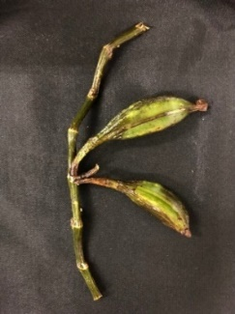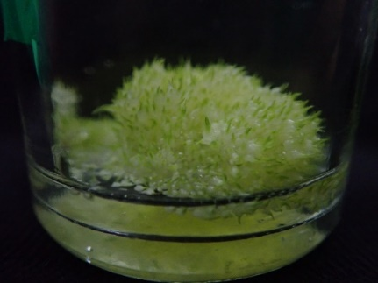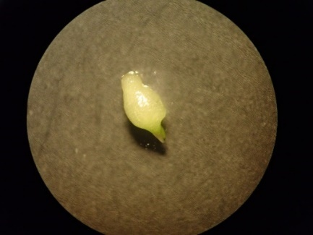
C
B
A
Figure 1. (A) Fully grown pods; (B) protocorms induced by seeds cultured on solid B5 medium for 12 weeks; (C) small, green protocorm at 20× magnification

After that, the protocorms were cultivated on both solid and liquid B5 media with plant growth regulator concentrations of 0, 0.5, 1, 1.5, and 2 mg/L BAP or mT for 8 weeks to induce shoots (Figure 2A-B). The cultures in liquid B5 medium were shaken on 150 rpm rotary shaker. After 8 weeks, the results found that the cultures on solid B5 medium provided 100 percent protocorm induction from all the medium formulas, except the medium without plant growth regulator (Table 1). The highest number of induced shoots was 1.6 shoots per explant from 2 mg/L mT (Figure 2C) followed by 1.5 and 1.4 shoots per explant from mT at 1.5 and 0.5 mg/L, respectively. The culture in B5 medium without plant growth regulator led to the lowest number of shoots. The most extended shoots from 1.5 mg/L mT was 9.82 mm (Figure 2D).
On the contrary, the shortest shoots derived from 1 and 1.5 mg/L BAP was 6.03 mm. The highest number of root induction was at 0.9 roots per explant. The longest roots length was 3.75 mm that obtained from 0.5 mg/L mT (Figure 2E) but there was no root induction from 1 and 1.5 mg/L BAP. At 2 mg/L mT provided the most average leaves, which were 3.7 leaves per explant (Figure 2F), but at 1.5 mg/L BAP was 0.7 leaves per explant.

Table 1. Percentages of protocorms that induced shoots, number and lengths of shoots, roots and number of leaves of D. chrysanthum Wall. ex Lindl. cultivated on solid medium B5 with various concentrations of BAP or mT for 8 weeks
Plant growth regulators |  | Induced shoot (%) | Shoots per explant | Shoots lengths^{/1} (mm) | Roots per explant | Roots lengths^{/1} (mm) | Leaves per explant
BAP (mg/L) | mT (mg/L)
0 |  | 90 | 0.90 | 6.99^{bc}±0.94 | 0.20 | 1.02^{bc}±0.82 | 1.10
0.5 |  | 100 | 1.00 | 6.61^{bc}±0.86 | 0.20 | 0.75^{bc}±0.54 | 1.00
1.0 |  | 100 | 1.00 | 6.03^{c}±0.78 | 0.00 | 0.0^{c}±0.0 | 1.00
1.5 |  | 100 | 1.00 | 6.03^{c}±0.69 | 0.00 | 0.0^{c}±0.0 | 0.70
2.0 |  | 100 | 1.00 | 6.95^{c}±1.17 | 0.10 | 0.41^{bc}±0.41 | 0.80
 | 0.5 | 100 | 1.40 | 7.53^{bc}±0.58 | 0.90 | 3.75ª±1.22 | 2.90
 | 1.0 | 100 | 1.00 | 8.75^{ab}±0.52 | 0.10 | 0.59^{bc}±0.40 | 2.20
 | 1.5 | 100 | 1.50 | 9.82ª±0.36 | 0.60 | 2.20^{ab}±0.81 | 3.40
 | 2.0 | 100 | 1.60 | 7.74^{abc}±0.47 | 0.30 | 1.59^{bc}±0.71 | 3.70
¹/ Values marked with the same letters were not significantly different at p < 0.05 based on Duncan's
multiple range test.

The cultures in the liquid B5 medium were developed 100 percent of protocorms that induced shoots from both mediums with, and without plant growth regulator after 8 weeks. The protocorms was prepared in a petri dish for measurement (Figure 3A-B). The highest number of induced shoots was at 1.1 shoots per explant obtained from 1.5 mg/L BAP; similar results were found from 1 and 1.5 mg/L mT (Figure 3C). The most extended shoots obtained from 1 mg/L mT were 13.98 mm (Figure 3D); in contrast, the shortest shoots from 1.5 mg/L mT were 7.49 mm. The highest number of roots was achieved from 1 and 2 mg/L mT (Figure 3E) and 2 mg/L mT, which also provided the longest root, which was 3.04 mm. There was no root induction from the medium without a plant growth regulator. The maximum number of leaves was 3.7 leaves per explant from 1 mg/L BAP (Figure 3F), whereas 1.5 mg/L mT was 0.3 leaves per explant, the minimum number of leaves, as shown in Table 2.

Table 2. Percentages of protocorms that induced shoots, number and lengths of shoots, roots and number of leaves of D. chrysanthum Wall. ex Lindl. cultivated on liquid medium B5 with various concentrations of BAP or mT for 8 weeks
Plant growth regulators |  | Induced shoot (%) | Shoots per explant | Shoots lengths^{/1} (mm) | Roots per explant | Roots lengths^{/1} (mm) | Leaves per explant
BAP (mg/L) | mT (mg/L)
0 |  | 100 | 1.10 | 8.02^{cd}±1.53 | 0.00 | 0.00^{d}±0.00 | 1.40
0.5 |  | 100 | 1.00 | 10.65^{bc}±1.34 | 0.10 | 0.17^{d}±0.17 | 1.50
1.0 |  | 100 | 1.00 | 13.97ª±0.51 | 0.20 | 0.18^{d}±0.17 | 3.70
1.5 |  | 100 | 1.10 | 13.86ª+0.79 | 0.20 | 0.49^{cd}±0.33 | 3.60
2.0 |  | 100 | 1.00 | 12.18^{ab}±0.86 | 0.60 | 1.41^{bc}±0.43 | 2.60
 | 0.5 | 100 | 1.00 | 11.90^{ab}±0.38 | 0.30 | 0.75^{cd}±0.40 | 2.00
 | 1.0 | 100 | 1.10 | 13.98ª±1.02 | 0.80 | 1.90^{b}±0.38 | 1.70
 | 1.5 | 100 | 1.10 | 7.49^{d}±1.22 | 0.10 | 0.44^{cd}±0.44 | 0.30
 | 2.0 | 100 | 1.00 | 14.1ª±0.49 | 0.80 | 3.04ª±0.71 | 1.80
¹/ Values marked with the same letters were not significantly different at p < 0.05 based on Duncan's
multiple range test.
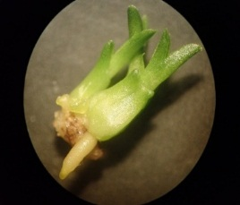
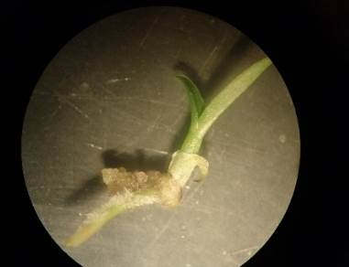
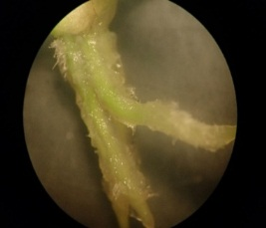
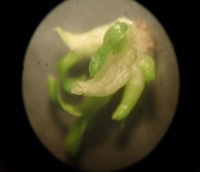
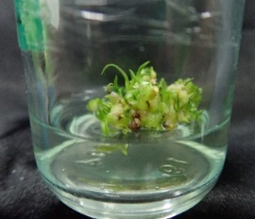
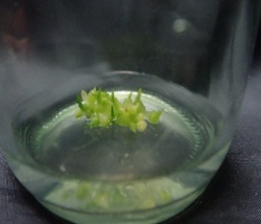
A
B
C
D
E
F

Figure 2. Protocorms cultivated on solid B5 medium for 8 weeks: (A) shoots induced at 2 mg/L mT at 20× magnification; (B) most extended shoots at 1.5 mg/L mT at 10× magnification; (C) roots induced at 0.5 mg/L mT at 20× magnification; (D) the maximum number of leaves at 2 mg/L mT at 20× magnification; (E-F) protocorms were cultured on solid B5 medium for 4 weeks and 8 weeks at 2 mg/L mT
E
D
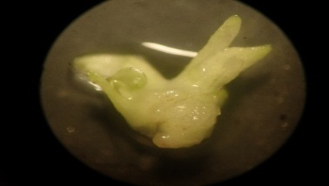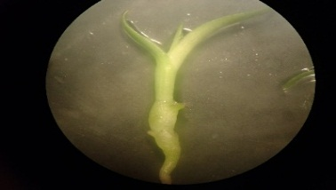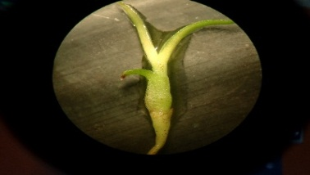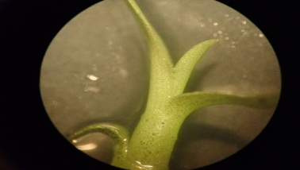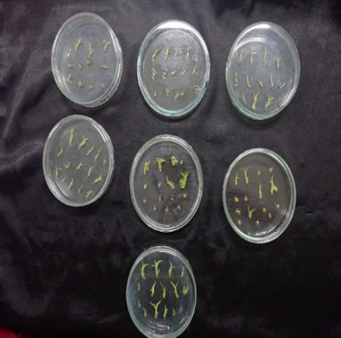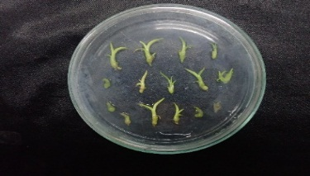
A
B
C
D
E
F

Figure 3. Protocorms cultivated on liquid B5 medium for 8 weeks: (A) shoots induced at 1.5 mg/L BAP at 20× magnification; (B) most extended shoots at 1 mg/L mT at 10× magnification; (C) roots induced at 2 mg/L mT at 10× magnification; (D) the maximum number of leaves at 1 mg/L BAP at 20× magnification; (E) collected protocorm on petri dishes prepared for measurement using a vernier caliper; (F) protocorm propagation at 1.5 mg/L mT
C
F

The protocorms were cultured on the solid and liquid B5 mediums for regeneration at 2 and 1 mg/L mT for 4 weeks. The plants were washed with tap water and soaked in fungicide. Then, the plants were transferred into the pots containing soil and coconut dust and were covered with plastic bags. After 4 weeks, the result showed that the plantlets could survive (Figure 4).

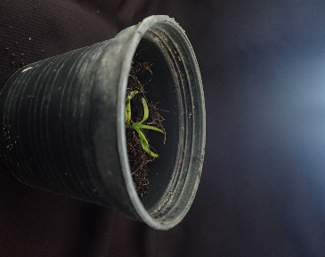
Figure 4. The plantlet cultivated on soil and coconut dust for 4 weeks
Discussion

At the beginning of this experiment, the mature seeds of D. chrysanthum Wall. ex Lindl. were cultivated on both solid and liquid B5 media. The minerals in nutrients may affect seed germination as Samala et al. (2014) compared with half-strength B5 medium or New Dogashima medium or half-strength MS medium supplemented with 0.1% activated charcoal (AC) for seed germination of Grammatophyllum speciosum. The half-strength B5 medium supplemented with 0.1% AC had the highest germination for 30 days. Parthibhan et al. (2012) studied seed germination of D. aqueum Lindley and used B5 vitamin replacement MS vitamin cultured on different strength MS medium. The result found that seeds responded with good germination as this result was similar to that of Hajong et al. (2010), who reported that nitrogen in the form of potassium nitrate in B5 medium could have accounted for the high germination percentage of D. chrysanthum seeds, which is consistent with this study of having 100 percent germination. On the other hand, Bhattacharjee and Islam (2014) studied the effects of plant growth regulators on multiple shoot induction in Vanda tessellata and found that MS medium was the most effective for seed germination compared with half-strength MS, PM (PhytamaxTM, Sigma, USA) and B5 medium.
The shoot and root induction of protocorm cultured on both solid and liquid B5 mediums showed an achieved target. As a result, it showed that the medium supplemented with mT gave a better result than the medium supplemented with BAP; the numbers and lengths of shoots, roots of D. chrysanthum Wall. ex Lindl. cultivated on liquid B5 medium with mT had better results than with BAP. Bose et al. (2017) reported mT was a highly effective plant growth regulator on shoot induction and regeneration of Malaxis wallichii compared with the cytokinin group. The most significant number of shoots was observed in MS medium supplemented with 1.0 mg/L mT and 0.5 mg/L NAA. Werbrouck et al. (2008) compared the culture of Spathiphyllum floribundum supplemented with mT and BAP and found that mT produced shoots with root formation; thus, mT is good an alternative for inducing shoot and root. Many studies commonly use BAP for seed germination and shoots induction. Regmi et al. (2017) studied protocorm propagation of Cymbidium aloifolium cultivated on MS medium containing various BAP or NAA concentrations. The best result of the shoot and root induction was found at 1 mg/L BAP and 1 mg/L NAA. Vijayakumar et al. (2012) reported BAP could activate shoot and root growth and the best seedling development of D. aggregatum when culture on MS medium combined with 1.5 mg/L BAP + 15% coconut water. Sharma et al. (2007) who studied shoot initiation from pseudobulbs of D. macrobulbon in high concentration BAP found that the highest number of shoots per explant were obtained at 2 mg/L BAP.
Acknowledgements

The authors would like to offer particular thanks to King Mongkut’s Institute of Technology Ladkrabang for granting a scholarship to carry out this research.

References

Bose, B., Kumaria, S., Choudhury, H. and Tandon, P. (2017). Insights into nuclear DNA content, hydrogen peroxide and antioxidative enzyme activities during transverse thin cell layer organogenesis and ex vitro acclimatization of Malaxis wallichii, a threatened medicinal orchid. Physiology and Molecular Biology of Plant, 23:955-968.
Bhattacharjee, H. and Islam, S. (2014). Effects of plant growth regulators on multiple shoot induction in Vanda tessellata (Roxb.) Hook. Ex G. Don an endangered medical orchid. International Journal of Science and Nature, 5:707-712.
Forest and Plant Conservation Research Office (2008). Dendrobium chrysanthum Wall. ex. Lindl. Wild orchids study guidebook 1, Bangkok, The Agricultural Cooperative Federation of Thailand. Limited., pp.66.
Gamborg, O., Mile, L. and Ojima, K. (1968). Nutrient requirements of suspension cultures of soybean root cells. Experimental Cell Research, 50:148-151.
Hajong, S., Kumaria, S., and Tandon, P. (2010). In vitro propagation of the medicinal orchid, Dendrobium chrysanthum. Proceedings of the Indian National Science Academy, 1:1-6.
Parthibhan, S., Benjamin, J., Muthukumar, M., Sherif, N., Kumar, T. and Rao, M. (2012). Influence of nutritional media and photoperiods on in vitro asymbiotic seed germination and seedling development of Dendrobium aqueum Lindley. African Journal of Plant Scienc, 6:383-393.
Regmi, T., Pradhan, S. and Pant, B. (2017). In vitro mass propagation of an epiphytic orchid, Cymbidium aloifolium (L.) Sw., through protocorm culture. Biotechnology Journal International, 19:1-6.
Samala, S., Te-chato, S., Yenchon, S. and Thammasiri, K. (2014). Protocorm-like body proliferation of Grammatophyllum speciosum through asymbiotic seed germination. Science Asia, 40:379-383.
Sharma, U., Rao, V., Mohan, J. and Reddy, A. (2007). In vitro propagation of Dendrobium microbulbon A. Rich―A rare ethnomedicinal herb. Indian Journal of Biotechnology, 6:381-384.
Sittichattham, S. (2012). Dendrobium chrysanthum Lindl. Wild orchid of Thailand, Bangkok, Bannlaesuanbook, pp.198.
Tongdonae, S. (2015). Study on the maintenance and survival of disputed conserved plants under plants act b.e 2518. in rescued centre, Nongkhai, Department of Agriculture, pp.23.
Vijayakumar, S., Rajalkshmi, G. and Kalimuthu, K. (2012). Propagation of Dendrobium aggregatum by green capsule culture. Lankesteriana International Journal on Orchidology, 12:131-135.
Wanthanaphuti, N. (2012). Dendrobium chrysanthum Lindl. Orchid, Bangkok, O.S. Printing House, pp.98.
Werbrouck, S., Strnad, M., Onckelen, H. and Debergh, P. (2008). Meta-topolin, an alternative to benzyladenine in tissue culture. Physiologia Plantarum, 98:291-297.

(Received: 25 May 2022, accepted: 30 July 2022)

∗Corresponding Author: Poeaim, A.; Email: anurug.po@kmitl.ac.th, anurug@hotmail.com

