Women and climate change impacts in Uganda: A review article

Nakiyemba, A.¹, Arayo, I.¹, Kennedy, W.¹, Joseph, K.¹, Branda, L. J.¹, Nandi, M. N.¹, Phillipson, M.¹ and Dayoub, M.²∗

¹Department of Natural Resource Economics, Faculty of Natural Resources and Environmental Sciences, Busitema University P.O.Box 236 Tororo, Uganda; ²Faculty of Technology, University of Turku. FI-20014 Turun yliopisto, Finland.

Nakiyemba, A., Arayo, I., Kennedy, W., Joseph, K., Branda, L. J., Nandi, M. N., Phillipson, M. and Dayoub, M. (2022). Women and climate change impacts in Uganda: A review article. International Journal of Agricultural Technology 18(6):2469-2476.

Abstract Climate change becomes the universally a major challenge facing humanity. The effects occur at global, regional, and local levels. It threatens the community, but not equally because women have limitations to access alternative resources such as movement to cities, jobs, and services. The climate change has impacted to women which increased in the levels of drought, death of livestock, scarcity of traditional food sources and water shortage in Uganda. There are decreased in crop production, loss of biodiversity, and solid fuels as firewood and charcoal for domestic use. Environmental degradation and human mobility are increased the availability of freshwater sources is reduced. There are also increased in wildfires, outbreaks of infectious diseases, climate-related displacements, armed conflicts, child marriages, human trafficking, epidemics, and gender-based violence. The quality of water for household use is reduced. The study showed that Ugandan women face different challenges from men because their societal roles have been constructed differently. Women in rural areas are depending mainly on natural resources more than men, therefore, they are more vulnerable to climate change. On other hand, women face socio-economic and political barriers and this makes them more susceptible and vulnerable to disasters. The study is emphasized the need for the development of robust support systems to cushion rural women from the vulnerable effects of climate change.

Keywords: Climate Change impacts, Women, Uganda

Introduction

Climate change is being known as a global crisis(UN, Women watch). The effects occur at global, regional, and local levels. It affects socio-economic systems that support human development a midst increasing global population projected to reach nine million by 2045 (Kamuntu, 2015).

United Nations Population Fund International Conference on Population and Development (Bernstein et al., 2007) recorded that the world is struggling to reckon with the basic human necessities of a thriving population as a result of disruptions by climate change which reduces goods and services derived from ecosystems. This has majorly affected sectors such as agricultural production, forest, water supply, health, and human development and yet the most vulnerable people like women and children have less coping mechanisms for mitigation and adaptation to climate impacts (Anon, 2015). As climate change intensifies with increased heatwaves, drought, rising sea levels and other factors such as the most women struggle during instability periods.

The vulnerability of people increased to rely a climate-related resources in food and water, deaths are increased due to droughts, fires, floods, heatwaves and storms which the spatial distribution of infectious diseases is also changed (Bernstein et al., 2007). The negative consequences of these circumstances can be experienced in agricultural production, food security, and water resources (UN, 2019). The objective was to find out how the impacts of climate change affecting the women in Uganda.

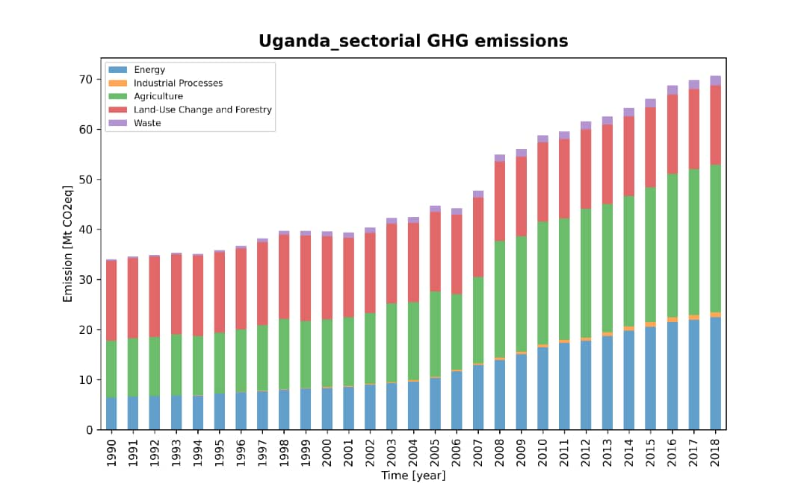

Figure 1. Uganda Sectorial GHG emissions, (Anon, 2022a)

Women and climate change impacts on natural resources

Increased levels of droughts

Droughts become more frequent and severe (Brüntrup, 2010). Drought is caused by climate change in the Karamoja sub region and in northern Uganda that get only one rainfall season in a year. The seven major droughts were reported in Karamoja region in 2001, 2002, 2005, and 2008 that faced the agricultural production, hydroelectricity production, pasture availability and water resources ( Kamuntu, 2015). It is well-documented to climate changes which would adversely impacted to agricultural production and staple foods for Ugandan diet leading to food security and consequently malnutrition (Ford et al., 2012); (Anon, 2013); (Thompson et al., 2010).

Increased water shortage

Climate change is negatively affected water supplies for home use around the world. Shortage of water in northern and eastern Uganda found that women has been searched for water in several kilometers for domestic use. Women are primarily responded for collecting and managing water to decrease in water availability which threatens in family livelihoods (Figure 2), increases workloads and affects primary school enrollment for girls (Anon, 2009b). Women including girls serve as labor for gathering food, water, and household energy resources in rural communities (McCarthy, 2020). Arsenic is contaminated in groundwater with flooding and exposed in rural communities leading to health problems as lesions and skin rash. The situation is worsed for women and girls who are shunned and excluded. It has affected their social life when it comes to marriage time and unmarried women are vulnerable to poverty shocks and sometimes are socially excluded from societies where they live (Anon, 2009b). Uganda with a population of over 45 million people, 7 million lack access to safe and clean water and 28 million do not have access to improve sanitation facilities.(Anon, 2022b)(Fagan, 2018).

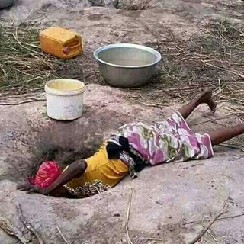

Figure 2. Woman collects water from a drying spring, courtesy photo Agago district Lapano village

Decrease, shortage and scarcity in traditional food sources

In the African culture, rural women are responsible for food production. Climate change brings about conventional food sources becoming more unreliable and rare leading to low harvests, low income, and increased food costs making it again unavailable to marginalized women and girls (Anon, 2009b). Most women involved in agricultural production experience a loss of income and harvests. This in the long run to increase food prices which in turn makes food more scares to poor people.

Loss of biodiversity and loss of species

Climate change is concerned the dominant driver of biodiversity loss in millennium ecosystem assessment. Biodiversity is important factor in climate change, adaptation and mitigation which concerns the natural habitats to reduce carbon dioxide that is released to the atmosphere. In Africa and Asia, women and men are depended on biomass e.g. firewood, charcoal for energy and financial capital. Climate change concerns the hinders the ability of women to access these resources. It leads to decline the biodiversity and primarily affected the poor people which mostly women in developing countries, and fish production is declined which affects the fisherman who rely on fishes (Anon, 2009b).

Reduced availability of solid fuels including firewood and charcoal for domestic use

Climate change can be made the used wood as a solid fuel source which located far from human settlements to create a burden on women and girls who collect the wood as traditional fuels for 2-20 hours per week or more. It leaves the women with less or no time to attend in other family and engages in community decision making activities. In most communities the girl-child is withdrawn from school to stay at home to collect firewood and contributes to the disempowerment cycle (Figure 3). They become more vulnerable to move in long distances and increased risk of offensive sexual advances from strangers, then they went to forests and woodlands where they collected the firewood (Anon, 2009b).

Climate change impacts on human

Increased outbreaks of infectious diseases and epidemics

Climate variability increases the rate of malaria outbreaks in the East African region. Women have involved the responsibility of caring for the sick in addition to inadequate access to medical facilities and services. This increases the amount of work and time spent on these activities and women have encountered fewer resources to enable them to adapt to the climate crisis and it is harder when dealing with female-headed households(Anon, 2009b). Climate variations increase the rate of mosquitoes in most parts of Uganda due to rising temperatures. Floods increase with climate change which leads an increase in the prevalence of waterborn such as cholera. An increase in such diseases has affected women’s health and their caregiving role to the families and the community (Anon, 2009a).

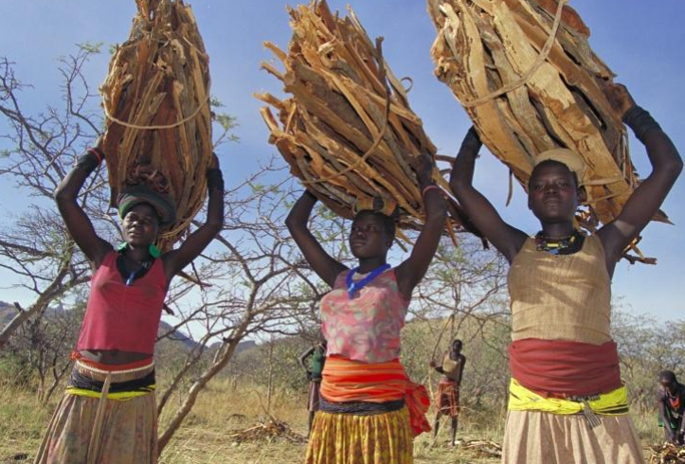

Figure 3. Women in Karamoja district trekking for solid fuel (Oxfam, 2011).

Increasing levels of climate-related arm with conflicts and displacements

Climate change is related to conflict and displacement, and women leave their homes for the bulk of those mandatory. The people displacement due to recurrent in droughts and political instability in many ways of climate change that affected to people in the worst impacts for women and the elderly who had shared the greater brunt of its negative consequences (Anon, 2016). Displacement conflicts are threatened women’s health eg pregnant women fail to receive the required medical care, and sometimes are unable to deliver safely under safe and hygienic conditions.

Increased levels of gender-based violence, prostitution and human trafficking

As climate change impacts the availability of resources due to droughts, flooding, and rising sea levels, gender-based violence increases. It is due to dwindling resources and decreasing in available land. In African culture, women are responsible for availing food, water and fire wood to family. Women are increased in the risk of violence and exploitation in the event of extreme weather. The situation is worsely happened when staying in temporary shelters. All these stressors are in the places which facilitate an enabling environment for organizations to participate in human trafficking and labor exploitation. Women, children and other marginalized groups are concerned most vulnerable to these violations. Climate change can be increased the economic burden on households, and results are concerned to land deprivation, income and security, the danger to marriage and marrying off girls are early becomes an adaptation mechanism to the impacts of climate change (McCarthy, 2020).

The migration of men

Migration of men affects the capacity of women who remain behind to cope with climate change impacts. Recently “Bararo pastolists” in Uganda who come from Masindi and entered to Apac district to search water and pastures for their cattle. The gendered impacts of male migration are focused while women revealed a greater labor responsibilities which is left behind the men and they do not have access to finance, social networks and knowledge. Women are often challenged by workload which exposed at home due to the loss of labor which provided by departed partners and other members of the household in addition to other household needs.

Women and access to services

Lack of accessibility to financial credit

Women lack collate security to access the credit and climb to decide the making positions. This increases vulnerability for climate impacts. The most women in Uganda are unable to access financial credit from banks and other institutions because they do not have security for the money. They are small farmers who own small businesses who unable to stand for financial credit. The women selling tomatoes or vegetables for living is an example.

Unequal access to resources

Women who are responsible for securing water, food and firewood for domestic purposes are challenged with limited access to resources and decision-making processes. Women in Uganda especially in rural communities are in a situation where they are divergently at risk of climate change impacts. Some areas that women have limited access to resources in Teso, Busoga and central Uganda (IA)

Dependency on the organic matter

Women in Uganda rely so much on firewood, crop waste, and timber for their cooking and needs. In the era of the climate crisis, the capacity of women attain these to assets a minimum. Women in Kole and Oyam districts are made on rids and other materials from the swamp to make mats and baskets due to long dry spells the swamps that dry up and no rids during the heavy pour. Flooding has made difficult for women to get the swamps and to obtain these materials (IA)

The women in Uganda have traditional coping and adaptive practices

Women's practices are included a strengthening local social manage climate change risks. The actions contain mechanisms of risk management. The connection between women and livelihood is revealed very strong and contained strong directly implications for sustainability and using the natural resources efficiently. The women have activated several means of conserving natural resources such as diver income, reforestation and planting trees in a home garden, and using modern irrigation for watering efficiency. Diversification of their crops is to alternate livelihoods and generate income during a drought season. They improve their ability to expand their farms. Diversifying can provide an opportunity to earn additional income such as food processing and dairy product (Wan et al., 2016).

Conclusion remarks

Climate change significantly has increased the drought, numbers of livestock, and shortage of water. At the same time, increased reduction in food sources and crop production. Women are increasingly being noticed as more vulnerable than men to the impacts of climate change.

What is important for the strategy of women to adopt climate change in Uganda requires to encourage women to improve their ability to expand their farms and diversify their crops as well as to go into alternate livelihoods. Development and improve women’s access to assets and finances loans and fair distribution of resources are involved. Educated women are created their own businesses and entrepreneurship in rural areas This enables women to access appropriate information technology, skills, and infrastructures like fertilizer and machines.

References

Anon (2009a). HUMAN DEVELOPMENT Effectiveness COORDINATI Efficiency.
Anon (2009b). Human Development Report 2009 Overcoming Barriers: Human Mobility and Development.
Anon (2013). Graduate Jobs Uganda: Jobs at Tetra Tech ARD in Uganda- Technical Specialists JOBS. Retrieved from http://onlinejobsmasters.blogspot.com/2013/02/jobs-at-tetra-tech-ard-in-uganda. html.
Anon (2015). Uganda: Environmental Assets Are Critical To Sustainable Urban Development. Retrieved from https://www.worldbank.org/en/news/press-release/2015/10/14/uganda-environmental-assets-are-critical-to-sustainable-urban-development.
Anon (2016). WOUGNET.” Retrieved from https://wougnet.org/.
Anon (2022a). OECD ILibrary. Retrieved from https://www.oecd-ilibrary.org/sites/9789264268265-7-en/index.html?itemId=/content/component/ 9789264268265-7-en).
Anon (2022b). Uganda’s Water Crisis. Retrieved from https://water.org/our-impact/where-we-work/uganda/).
Bernstein, L., Bosch, P., Canziani, O., Chen, Z., Christ, R. and Riahi, K. (2007). Climate Change 2007 Synthesis Report, 104.
Brüntrup, M. (2010). IGAD Case Study. Retried from https://www.preventionweb.net/files/78465_cs8.michaelbrntrupcasestudyeastafri.pdf
Fagan., Richard B. Asaba. National University of Ireland. G. Honor. (2018). Women and Access to Water in Rural Uganda: A Review.
Ford, James D., Vanderbilt, W. and Berrang-Ford, L. (2012). Authorship in IPCC AR5 and Its Implications for Content: Climate Change and Indigenous Populations in WGII. Climatic Change, 113:201-13.
McCarthy, J. (2020). Understanding Why Climate Change Impacts Women More Than Men. Retrieved from https://www.globalcitizen.org/en/content/how-climate-change-affects-women/.
Oxfam. (2011). Investigation into the Eviction of More than 20,000 Ugandans. Retrieved from https://www.oxfam.org/en/press-releases/investigation-eviction-more-20000-ugandans-must-ensure-justice-affected-people.
Thompson, H. E., Berrang-Ford, L. and Ford, J. D. (2010). Climate Change and Food Security in Sub-Saharan Africa: A Systematic Literature Review. Sustainability, 2:2719-2733. doi: 10.3390/SU2082719.
Kamuntu, E. (2015). Uganda National Climate Change Policy. Retried from https://www.mwe.go.ug/sites/default/files/library/National%20Climate%20Change%20Policy%20April%202015%20final.pdf
UN. (2019). WomenWatch: Women, Gender Equality and Climate Change. Retrieved from https://www.un.org/womenwatch/feature/climate_change/.
Wan, J., Li, R., Wang, W., Liu, Z. and Chen, B. (2016). Income Diversification: A Strategy for Rural Region Risk Management. Sustainability 2016, 8:1064. doi: 10.3390/SU8101064.

(Received: 15 September 2022, accepted: 30 October 2022)

∗ Corresponding Author: Dayoub, M.; Email: moammar.dayoub@utu.fi

